EQUESTRIAN FEDERATION OF INDIA
Tele : 25683601 C/o ‘B’ Sqn, 61 Cavalry
Fax : Cariappa Marg,
E-mail : efiindianf@yahoo.co.in Delhi Cantt – 110 010
Website : www.equestrian-india.org

072/EFI/2018 04 Nov 2018

Shri A K Patro
Under Secretary to the Govt of India
Ministry of Youth Affairs and Sports (SP-III)
Shastri Bhawan, New Delhi

Registrars of Societies
12/1 DC Office, Jam Nagar
India Gate, New Delhi

57th ANNUAL GENERAL BODY MEETING : EQUESTRIAN FEDERATION OF INDIA

Dear Sir,

1. Reference to this Federation letter No 072/EFI/2018 dated 31 Aug 2018.

2. The Annual General Body Meeting of this National Federation was held on 30th Sep 2018 at Manekshaw Centre, New Delhi. The AGM was conducted as per the Government Guidelines and Bye Laws as mentioned in the statutes.

3. Minutes alongwith appendices of AGM 2018 of this Federation are attached alongwith Statutes amendments. The Minutes of AGM are also available on our web page : www.efing.org . The following documents are also attached :-

- Copy of AGM Notice containing the audited statement of account as per ‘A’
- List of participants/Members who attended the AGM attached as appendix ‘B’
- List of Govt employees elected in the AGM and their respective NOC obtained from the employers are attached as Appendix ‘C’
- list of elected members, elected unopposed is attached as per appendix ‘D’

With warm regards
Yours sincerely,

Sd/-xx-xx
( R K Swain)
Colonel
Enclosures : As above Secretary General

Copy to :-

Director Sports - For information alongwith a copy of AGM Minute.
Sports Authority of India and above documents.
Jawaharlal Nehru Stadium
Lodhi Road, New Delhi-03

Secretary General - -do-
Indian Olympic Association
Olympic Bhavan,B-29, Qutab Institutional Area
New Delhi

MINUTES OF 57TH ANNUAL GENERAL BODY MEETING OF EQUESTRIAN FEDERATION OF INDIA HELD ON 30TH SEP 2018 AT MANEKSHAW

CENTRE,DELHI CANTT

1. The 57th Annual General Body Meeting of Equestrian Federation of India was held on 30th Sep 2018 at Manekshaw Centre, Delhi Cantt under the Chairmanship of Lt Gen Ashok Ambre, AVSM**, SM, President EFI. The meeting was attended by 138 members.

2. Opening address by the President

2.1 The President welcomed all the present members of EFI to the 57th Annual General Body Meeting. The President apprised the house, that the quorum to conduct the AGM has been fulfilled and we can proceed with the proceedings of the AGM.

2.1.1 The President congratulated the Eventing Team of the 18th Asian Games 2018 which won both the individual and team silver medals. This achievement has been after a gap of 36 years and all members of the team are required to be given a big round of applause for making the country and federation proud. The President also took the opportunity to compliment and thank Mr Jitu Virwani, VP (Finance), Chairman Embassy Group for sponsoring the eventing team in terms of provisioning of quality horses and training in Europe. The President also complemented the members of the Show Jumping Team to the 18th Asian Games who put up a commendable show at the Asian Games.

2.1.2 The President complemented the team which qualified for World Cup qualifiers Tent Pegging by securing 1st position within the group out of four countries. The President conveyed best wishes to the team which will be competing in Oct 2018 at UAE.

2.1.3 The President congratulated the Federation and all its members on being awarded the FEI Solidarity Award for the year 2017 which has been an honour to the federation and the sport from which the sport has gained a lot.

2.1.4 The President apprised the house about the present functioning of EFI and reiterated that all correspondence of importance is put up to the president and no arbitrary decision is taken in EFI by any of the office bearers of the federation. He applauded the staff of the Federation for doing a commendable job over the past year.

2.1.5 The President complemented RVC Centre and College, Meerut Cantt for establishing the EDFZ at Meerut and successfully following the pre export vet protocols required for exporting horses for the 18th Asian Games 2018. The President stressed upon the fact of the requirement of a permanent EDFZ at Meerut and suggested the involvement of the state association in facilitating the same. The President also suggested of having one EDFZ in south India preferably in Bangalore.

2.1.6 The President appreciated the efforts of EFI in conducting various coaching camps held during the year including the FEI Solidarity Coaching Camps. The President further brought out that as a federation and country, we are lacking behind in good quality coaches and trainers for various equestrian disciplines and more focus is required on coaches and trainers alongside participants.

2.1.7 The President apprised the house that the recognition of the federation by Ministry Youth Affairs and Sports (MYAS) have been received and is valid upto 31 Dec 2018.

2

2.1.8 The President informed the house that there is a need to shift the office of the federation out of the military area and requested the committee detailed to acquire the office space to expedite and finalise the project as early as possible.

2.1.9 The President expressed his displeasure regarding the discipline aspect of certain athletes of the federation in which athletes have been crossing the limit in regard to rules, regulations and orders in conduct of trials for the 18th Asian Games. The orders were clear that no exclusive trials would be accepted, however a number of athletes have violated this and staked claim of qualification based on the results of exclusive trials held by them. Participants even went further to challenge the federation decision for which the federation had to spend a large sum of money as legal fees to counter the claim in the Honourable High Court.

2.1.10 In regard to discipline and court cases by various members of the federation, The President left the decision to be taken by members of the federation present at the AGM.

2.2 He then handed over the proceedings to the Secy Gen.

AGENDA I

3. Confirmation of the Minutes and Progress on the Points of Last AGM. The Secy Gen informed the house that minutes of the last year AGM held on 27th Aug 2017 are available on EFI website. On request for passing the minutes the same was proposed by Dr Sanjay Gupta and seconded by Brig Sameer Lanba, VSM respectively.

AGENDA-II
4. Secretary General’s Report.

Points | Decision/Directions | Action to  be taken by
4.1 Results of all events held during the EFI Calendar year 2017-18:- The Secretary General informed the house that results of all events for the Calendar year 2017-18 were uploaded in the Federation website after conclusion of each event. He then briefed the house on the results of all major events. Results of all events are attached at Appx‘A’. | Decision of the house Results of all the events were perused by the house and ratified. | All
4.2 FEI Solidarity Awards. The Secy Gen informed the house that four countries i.e. India, UK, Canada and Ireland were nominated for FEI Solidarity Awards. With the support of all and voting through social media India has won the FEI Solidarity Award. | Decision of the house The President congratulated all members of the Federation. | All

3
Points | Decision/Directions | Action to  be taken by
4.3 Election of Executive Committee Members : 2017 :- EOGA was scheduled on  30 Sep 2017 to hold election for vacant posts in Executive Committee. However the following were declared elected unopposed due to single nomination :-  (a) President – Lt Gen Ashok Ambre, AVSM**, SM.  (b) VP (Adm) - Lt Gen MH Thakur, VSM.  (c) JT Secy - Col Manraj Singh Sandhu. | The house ratified the same unanimously. | VP (Adm)  Secy Gen
4.4 Office Bearers of the Secretariat. The Secy Gen informed the house that the following appointments have resigned :-  (a) Joint Secy - Col MS Sandhu  (b) Treasurer - Col BVS Rao  (c) Regional Member (South) - Maj KD Malik  (d) VP(Vet) - Lt Gen AJ Singh  The President has nominated the following members during the EC :-  (a) Joint Secy - Lt Col MM Rahman  (b) Regional Member (South) - Mr Kishor Futnani | The house ratified the same unanimously.
4.5 Secretariat Functioning. The Secretary General informed the house about the various activities reqd to be done by EFI secretariat before the conduct of each events. He also mentioned that 35 to 40 events are being conducted every year since 2015 against just 12 to 15 events during previous years. As a result of this the work load on the secretariat has increased many fold. Details of the same are attached at Appx ‘B’. To accomplish the secretariat functioning EFI has employed two clerks borrowed from other organisations and an Assistant Secretary has been employed by MYAS. These personnel do not get HRA from their parent organisation therefore Secretary General had recommended that these personnel be given HRA as per Govt norms out of EFI Fund. Further he had recommended that there is an urgent need of employing a Data Entry Expert (DEE) for smooth functioning of the secretariat. Both the recommendations were approved by the Executive Committee. | Decisions of the House: The house approved and ratified the same. | VP (Adm)  Secy Gen

4
Points | Decision/Directions | Action to  be taken by
4.6 EFI Office Property. The Secretary General informed the house that the Committee comprising of the following members have visited various places and have finalised the loc of Bikaji Kama Place for EFI Office :-  (a) Lt Gen AJ Singh, AVSM, VSM, Vice President (Vet)  (b) Mr Jitendra Virwani, VP (Fin)  (c) Brig GS Puri, VP (Tech)  (d) Brig SS Kashyap, VP (Sports Devp)  (e) Col RK Swain, Secy Gen  (f) Mr Sanjay Gupta, Member Central  Mr Jitu Virwani, VP (Fin) has expressed voluntary contribution from his side towards renovation of the complete EFI Office once the property is acquired. | Decisions of the House: The house approved and ratified the same. President directed that the property be acquired without any more delay. | VP (Adm)  VP (Fin)  Secy Gen
4.7 FEI WDC Points. The Secretary General informed the house that due to change of nomenclature of WDC events there is a need to change FEI WDC rider points. Details of the same are attached at Appx ‘C’. | The details perused by the house and approved. | VP (Tech)  Secy Gen
4.8 Reduction of Membership Fee. The Secretary General informed the house that during the AGM 2017 held on 27th Aug 2017 a point was raised by the house for reduction of membership fee. He had proposed that the life membership fee be reduced to 7,000/- and club/ unit membership fee be reduced to 3,000/- which was approved by the EC. Details of the same are attached at Appx ‘D’. | Decisions of the house: The house approved and ratified the same. | VP (Adm)  Secy Gen

5
Points | Decision/Directions | Action to  be taken by
4.9 Chhattisgarh Equestrian Association. The Secretary General informed the house that Chhattisgarh Equestrian Association affiliated with this NF since 2001 has requested for cancellation of their affiliation. The above Association has recommended grant of affiliation to Mrs  Geeta Singh of Chhattisgarh Association. One more application has been recd for EFI membership of State Association from Mr Sachin Tiwari who has not obtained NOC from State Olympic Association nor provided the membership form. Hence, the same has been returned to them without action. He had recommended that membership of the Chhattisgarh Equestrian Association be cancelled and any association having NOC from State Olympic Association may be granted affiliation with this NF. The same was approved by the EC. | The details were perused by the house and approved. | VP (Adm)  Secy Gen
4.10 Coffee Table Book. The Secy Gen informed the house that Col SS Ahlawat, VSM (Retd), member Dressage has suggested that a Coffee Table Book of EFI be Published. He further informed the same was passed during the AGM in 2010 and some amount of work has already been done by Ms Jillian which can be further developed to publish a fresh Coffee Table Book. The President gave the go ahead for publication of new Coffee Table Book.  Present Status :-  Expected Date of final approval - 18th Oct 2018  Ready to print dummy - 22nd Oct 2018  Printing - 23rd Oct to 10th Nov 2018  Delivery of 1,000 copies - 15th Nov 2018  Publisher : ARB Interactive | The house praised the initiative of the Federation and approved the finalisation of Coffee Table Book. | VP (Vet)  Secy Gen
4.11 Annual Recognition. The Secy Gen informed the house that the affiliation of EFI by Ministry of Youth Affairs and Sports has been extended upto 31st Dec 2018. | Details perused by the house.
4.12 Participation Certificate in NEC Show Jumping. The Secy Gen apprised to the house that the riders who have qualified and participated in National Level Show Jumping through the process of Regional Equestrian League (Show Jumping) selection should be given participation certificate at National Level if requested by them. | Details perused by the house and approved. | VP (Tech)  Secy Gen

6
Points | Decision/Directions | Action to  be taken by
4.13 Implantation of Microchip in Horses. The Secy Gen informed the house that it has been intimated by FEI that no new horses will be accepted for FEI registration without implanting a microchip. FEI is not accepting any new entry of horses in FEI events without a microchip. All riders have been advised to get their horses implanted with microchip to enable themselves to participate in FEI events. The horses already registered with EFI have also been advised to get microchips implanted to avoid inconvenience at a later stage. The details of the microchip implanted in horses are reqd to be intimated to EFI office for incorporation in their passports.  The Microchips are available at the following address and cost of the microchip is approximately Rs 175/- :-  M/S ALLFLEX INDIA PVT LTD  573, 3RD FLOOR, MAIN ROAD  CHIRAG DELHI-110017  M/S PET PULSE  SF-35, 2ND FLOOR  VYAPAR KENDRA  SUSHANT LOK-1  GURGAON -122009  PETPULSE@GMAIL.COM PH : 7042623905 | Details perused by the house. | VP (Vet)  Secy Gen
4.14 Vet Protocol and EDFZ. The Secretary General informed the house that the vet protocol of 18th Asian Games has been received and the President Congratulated RVC Centre ad College, Meerut for their effort to get the EDFZ Meerut sanctioned by VET Authority. | The house perused the matter and decided to continue with the EDFZ without denotification.

7
Points | Decision/Directions | Action to  be taken by
4.15 REL for JNEC and Tent Pegging. The Secretary General informed the house that there is a growing demand from the environment to conduct REL for JNEC as well as Tent Pegging. The matter was discussed during the EC and it was approved that REL will be conducted for the JNEC and Tent Pegging from the present EFI Calendar.  Advantage/ Disadvantage of Selection of JNEC Riders through REL Advantages  (a) Worthy riders will come up for JNEC  (b) Junior riders will have more exposure  (c) Business for clubs by leasing horses  (d) No pressure on parent for leasing for the finals as demand and supply balance will be maint  (e) Parents of only selected riders have to move to the venue – no pressure on accn and allotment of horse  (f) JNEC can be conducted in 5 to 6 days  (g) Expenditure on officials reduced  (h) Coaching Camp for selected riders PRIOR to JNEC.  Disadvantages  (a) Less entry fees to EFI  (b) JNEC will not be lucrative for bidding by clubs | The house perused the decision of the EC and approved. | VP (Tech)  Secy Gen
4.16 Regional Equestrian League (REL) Guidelines and Course Plans. The Secy Gen informed the house about the reformulation of Regional Equestrian League (REL) Guidelines and Course Plans. The Secy Gen also apprised the house regarding representation received from some members objecting to IMA/OTA/NDA Cadets being exempted from qualifying in two RELs to be eligible for JNEC. The same clause was discussed during EC meeting and removed. Amended REL Guidelines and Course Plans attached as Appx E.  Member Tent Pegging proposed that the Horse Rider combination should not be made mandatory for participation in NEC through REL | Details perused by the house and after due deliberation the REL guidelines were amended further and approved. The amended REL guidelines are attached at Appx ‘F’. | VP (Tech)  Secy Gen  Member (Tent Pegging)
4.17 Sport Horse Stud Book. The Secy Gen informed the house that a request has been received from EIRS to issue a letter by EFI to recognize the Sports Horses Stud Book India LLP. After detailed discussion EC approved the issue of letter of recognition and Mr Jitu Virwani, VP (Fin) further added that 20% of the earning of the same will be deposited to EFI. | Details perused by the house and the decision of EC ratified. | VP (Adm)  Secy Gen
8
Points | Decision/Directions | Action to  be taken by
4.18 Visit of FEI President. The Secy Gen informed the house that Mr Ingar De Vos, President of the FEI visited India wef 21-24 Apr 2018. | Details perused by the house.
4.19 Stabling Charges. The Secy Gen informed the house regarding representation received from various members to raise the point of exorbitant stabling charges being charged by various clubs/ institutions during the conduct of events. The house unanimously decided to leave the issue of stabling charges to the Organising Committee (OC) of the event wherein details should be provided in the General/ Technical instructions provided by the OC after due consultation with EFI and Technical Delegate of EFI to verify facilities provided. Basic facilities of over head shelters, light, water and disposal of litter and toilets of adequate nature should be provided by the OC. | Details perused by the house. | VP (Tech)  Secy Gen
4.19. 1st Asian Equestrian Federation (AEF)  U-21 Dressage Championship 2018. The Secy Gen informed the house that 1st Asian Equestrian Federation Championship-2018 will be conducted at Doha (Qatar) wef 15-17 Nov 2018 on borrowed horses. The Secy Gen also informed that Zonal Qualifiers (Max 40 Riders of every NF ) will be held at the following locations :-  (a) 61 Cavalry, Jaipur (Rajasthan) on  09 Oct 2018.  (b) Chennai Equestrian Academy, Chennai, Tamil Nadu on 11 Oct 2018.  Officials :-  (a) Mr Yeh, Yi-Cheng - President Ground Jury  (b) Mr Li-Cheng-Hsien - Ground Jury Member  Zones :- | Details perused by the house | VP (Tech)  Secy Gen
  Zone - I :-  (a) Kyrgyzstan  (b) Singapore  (c) Malaysia  (d) India | Zone - II :-  (a) Indonesia  (b) Thailand.  (c) Chinese Taipei.

9
Points | Decision/Directions | Action to  be taken by
4.20 Improvement In Website. The Secy Gen informed the house that improvements have been carried out in the EFI Website with inclusion of online payment portal. The website has been upgraded to be IOS compliant. New EFI Mobile app has also been launched for quick update of information. | Details perused by the house | Secy Gen
4.21 Affiliate Membership (AFM). The Secy Gen informed the house at present the following Affiliate Membership (AFM) with EFI and proposed to convert them into club members/ discontinue.  - All India Marwari Horse Society of India - AFM-01  - Indigenous Horse Society of India - AFM-02  - Para Equestrian Society of India - AFM-03  The EC after detailed discussion directed the Secy Gen to write to these organistions and seek their willingness whether to convert their membership or discontinue and take action as per their willingness.  All India Marwari Horse Society of India has expressed interest to obtain the Federation club membership. | Details perused by the house | Secy Gen
4.22 Bid Form. The Secy Gen put forward the new bid form approved by the EC for the perusal of the house. The same is also attached as Appx ‘G’. | Details perused by the house and ratified. | VP (Tech)  Secy Gen
4.23 Composition of Selection Committee. The Secy Gen informed the house as per MYAS Letter F.NO. 12-I/2018-SP-III dated 08 Jan 2018 (copy attach as Appx ‘H’) the composition of Selection Committee shall consist of :-  (a) President of the National Federation as the Chairman.  (b) National Coach if appointed.  (c) 05 Members elected by the General Assembly. | Details perused by the house. | VP (Adm)  Secy Gen

10
Points | Decision/Directions | Action to  be taken by
4.24 JNEC-Tent Pegging. The Secy Gen informed the house that a request was received from Mr Ahmed Afsar to include all eight Categories of Tent Pegging in JNEC. After detailed discussion only 04 categories for the JNEC i.e. Lance (Indl), Sword (Indl), Lemons & Peg (Sword) and Rings & Peg (Lance) have been approved by the EC to be included in JNEC. | Details perused by the house and ratified. | VP (Tech)  Secy Gen
4.25 ITPF General Assembly. The Secy Gen informed the house that ITPF General Assembly was held at Khasab on 27 Jan 2018 and was attended by Col TS Warrich, Member Tent Pegging. | Details perused by the house
4.26 FEI General Assembly 2018. The Secy Gen informed the house that the FEI General Assembly is scheduled to be held at Manama, Bahrain wef 16-20 Nov 2018 and the EC has approved the attendance of President and Secy Gen, EFI. | Details perused by the house and ratified. | Secy Gen
4.27 FEI Course for NF Secretary General’s & NF Administrators. The Secy Gen informed the house that FEI is conducting a course for Secretary General and NF Administrators at Lausanne, Switzerland wef 22-26 Oct 2018 in which Secretary General, EFI and Assistant Secretary, EFI have been invited to attend. Out of 134 NFs, 17 NFs have been invited amongst which our NF is included. The EC has approved their attendance. | Details perused by the house and ratified. | Secy Gen
4.28 Annual Professional Fee of Chartered Accountant. The Secy Gen apprised the house that professional fee for the CA is Rs. 1,00,000/- (Rupees one lakh) plus GST for the financial year 2018-19. Fee will be increased @10% per annum. The professional fee for Assessment/ Appeal/ CBDT proceeding will be charged separately. | Details perused by the house and ratified. | VP (Fin)  Secy Gen
4.29 Transportation for EFI Secretariat. The Secy Gen apprised the house that the then VP (Adm) during his presentation to EC on Nov 2015 had proposed to have a dedicated transport for EFI Secretariat. EC after detailed discussion and keeping the state of account at that point in mind had suggested that instead of having a dedicated transport, EFI should hire a transport as and when required. Now with the improved state of fund it is suggested that the time has come to have a dedicated transport for EFI Secretariat. If approved a veh in the range of 10 to 15 lakhs should be bought for EFI and a driver be appointed with a salary of approx Rs 15,000/- per month. | Details perused by the house and approved. | VP (Adm)  VP (Fin)  Secy Gen
11
Points | Decision/Directions | Action to  be taken by
4.30 Election of Executive Committee Members : 2018 :- Under the authority of Annual General Body Meeting Notice No 072/EFI/2018 dated 25th Aug 2018, the election committee members assembled at EFI Office on 20th Sep 2018 at 1500h for opening the Nomination Box. However the following were declared elected unopposed due to single nomination :-  VP (Vet) - Lt Gen PR Venkatesh  Treasurer - Col Manoj Yadav  Joint Secretary - Lt Col MM Rahman  Regional Member (South) - Mr Kishore Futnani | Details perused by the house | VP (Adm)  Secy Gen
4.31 Neesha Khatau (Court Case). The Secy Gen informed the house that a court case was filed by Mrs Neesha Khatau on behalf of her daughter Ms Smarah Malaney. The individual has levelled charges that the Selection Trials parameter for Dressage have not been invoked equally for riders abroad and in India. The individual participated in four trials and did not qualify and feeling aggrieved filed a Petition on 19 Apr 2018 and subsequently withdrew the case on 11 Jul 2018 and the case was disposed off by the Hon’ble High Court as such. Legal expenses towards the case were Rs 1,78,200/- | Details perused by the house and ratified.
4.32 Balaji Vijayshankar and Yashaan Khambata (Court Case). The Secy General informed the house that Balaji Vijayshankar, Yashaan Khambata and  Sehaj Singh Virk under took exclusive trials at Luxembourg which were not recognised FEI/  National Events based on which the trials were not considered by the Selection Committee of the 18th Asian Games 2018. In grievance to the above,  Balaji Vijayshankar and Yashaan Khambata filed a writ petition in the High Court on 25th Jun 2018 and a 2nd petition on 2nd Jul 2018. Finding no merit in case the High Court disposed off the case on 09th Jul 2018. Legal expenses towards the case is Rs 10,50,000/-. | Details perused by the house and ratified.

12
Points | Decision/Directions | Action to  be taken by
4.33 Angad Sahlot (Court Case). The Secy Gen informed the house that Mr Angad Sahlot has filed criminal case against Col Rajiv Kumar Dahiya who was the then Joint Secretary of the Federation. The court ordered Secy Sports to hear both the parties and resolve the issue. Mother of Angad Sahlot made a request to Secy Sports to include her son’s name in the 18th Asian Games Show Jumping Team despite not having competed in any of the Asian Games trials held. The Secy Sports disposed the case finding no merit in the case. Legal expenditure of the case so far is  Rs 2,09,000/- . Secretary General further informed the house that a quashing petition has been filed in the High Court to close the case. | Details perused by the house and ratified.
4.34 FEI Solidarity Coaching Camp : Eventing & Show Jumping. The Secy Gen informed the house about FEI Solidarity Coaching Camp for Eventing and Show Jumping. The details of coaching camps are attached at Appx J. | Details perused by the house
4.35 ACTC Coaching Camp : Show Jumping & Dressage. The Secy Gen informed the house about the ACTC Coaching Camp for Show Jumping and Dressage. The details of coaching camps are attached at Appx K. | Details perused by the house
4.36 FEI Solidarity National Coach Development Programme. The Secy Gen apprised the house that a coach development programme has been sponsored by FEI with financial assistance of CHF 10,000/- over a period of two years. The aim of the programme is development of National Coach Education and Certification. First FEI Solidarity Coaches Tutors Workshop was held at AEN c/o RVC Centre and College, Meerut wef 10-14 Sep 2018 with participation of 15 coaches under coordinator Jean-Phillippe Camboulives. | Details perused by the house
4.37 Detailment of Indian Official as Member of Jury/ TD in International Events: - The Secretary General informed the house that Indian officials are now being invited as member of Jury/ TD in international events. The details are attached at Appx ‘L’. | Details perused by the house

13
Points | Decision/Directions | Action to  be taken by
4.38 FEI Technical Delegate Promotion Course.  The Secy Gen apprised the house that the FEI Technical Delegate Promotion Course was held at Minsk, Belarus from 26-29 Jul 2018. Comdt Naresh Tehlan attended the course and has been approved. Lt Col Bharat Rathore has been promoted to FEI 2* Endurance Judge and Technical Delegate after attending a course at Terenganu International Endurance Park, Malaysia from 28 Jun to 01 Jul 2018. | Details perused by the house | VP (Tech)  Secy Gen
4.39 State of Funds. The Secy Gen appraised the house on the state of funds available with the federation. The details of the same attached as Appx ‘M’. | Details perused by the house
4.40 Transportation of Horses. The Secy Gen apprised the house that the horses were located at the following places :-  Eventing Horses  France - 03  Germany - 01  Show Jumping Horses  Netherlands - 01  India/ Thailand - 03  The Secy Gen informed the house that  Rs 91,50,151/- has been paid to Peden and Bloodstock for transportation of 05 horses from Europe to Jakarta and back and Rs 1,25,97,839/- has been paid to Trans Air Cargo Pvt Ltd for transportation of 03 horses from Chennai to Thailand, Thailand to Jakarta & back to Chennai. A total of Rs 1,84,26,990/- has been paid from the Federation Fund and Rs 33,21,000/- has been paid by Mr Kevic Setalvad as approval of budget from MYAS has not been confirmed. Subsequently, when the funds are released from the Govt. the same will be reimbursed to the Federation account and concerned people. | Details perused by the house | VP (Fin)  Secy Gen

14
Points | Decision/Directions | Action to  be taken by
4.41 Income Tax Penalty. The Secy Gen informed the house that during 17th Asian Games an approx amount of Rs 1,32,67,932.22/- has been paid to agencies outside India. No exemption was obtained for payment to agencies abroad. During scrutiny the matter had come to the light of Income Tax official who have raised a penalty of Approx Rs 73 lacs on EFI. An initial amount of Rs 14,74,250/- has been paid and at the same time an appeal has been filed to waive off the penalty.  CA has assured to the EC that he will get back the money through refund.  Presently case has been taken up with CBDT to avail exemption under 11 (1) C for the year 2014-15, 2015-16, 2016-17, 2017-18 and 2018-19. | Details were perused by the house. | VP (Fin)  Secy Gen
AGENDA III
5. Passing of Accounts. The Secy Gen flashed the details of accounts Income & expdr for the FY 2017-18 as per AGM notice before the house and asked some one to propose the passing of accounts if there is no observation/ objection.  At this juncture Lt Col Sandeep Dewan (Retd) pointed out that the account cannot be passed as he has certain observations on accounts which are as follows :-  (a) Expenditure incurred by the Secretary General in hiring of civil hired transport.  (b) Huge sum expended on foreign travel by Secretary General for attending various FEI/ AEF AGM and Sport Forum.  (c) Huge expenditure on court cases.  (d) Huge sum spent on horse transportation and feed for Asian Games 2018.  In reply to the above Lt Gen MH Thakur, VSM, VP (Adm) EFI asked Lt Col Sandeep Dewan (Retd) whether he was given opportunity to check the accounts or not. In response to which Secy Gen informed that, although the last date for checking the account was 10th Sep 2018, Lt Col Sandeep Dewan (Retd) was told by Secy Gen personally that he may check the accounts even one day prior to AGM as per the time suitable to him which he did. | Decisions of the house. The accounts were passed after being proposed and seconded by Dr Sanjay Gupta and Brig Sameer Lanba, VSM respectively. | VP(Fin) Secy Gen

15
Points | Decision/Directions | Action to  be taken by
VP(Fin) told the house that it is necessary that EFI is represented by someone in the international forum and meets and Secy Gen is the right person for the same. Hence, the expenditure on his foreign travel is justified and not an aberration. With regards to the huge sum spent in court cases Mr. Kevik Setalved appraised the house that the legal fees paid to the advocates is minimal and justified keeping the nature of the case. He himself was involved in the complete process and assured the house that the expenditure is fully justified. Keeping in view the nature of judgement which we have got from a very reputed judge which is a benchmark judgement and the same can be referred by many NFs in times to come, the expenditure incurred is justified. He also stated if we had not got this judgement in our favour then separate petition would have been filed against EFI by Dressage riders who also had adopted similar practices in giving their Asian Trials in Austria. Keeping all the above in view and employment of reputed lawyers to defend the case the cost involved is not too much. It further has saved the reputational loss of EFI. With regards to the expenditure of huge sum in transportation of horses and feed during the 18th Asian Games. Col Rajeev Dahiya the team manager explained that all the expenditure is bonafide and has been paid out of EFI fund as the Govt has not released any advance however the same will be claimed from the MYAS. At this juncture Lt Col Sandeep Dewan (Retd) brought out that MYAS has given approx 20 Lakhs for Asian trial however no amount have been given to EIRS who have conducted Asian Traials for show jumping. In response Secy Gen informed the house that for the first time in the history of EFI MYAS was persuaded to release funds for Asian Trials and they approved fund for only Eventing and Dressage trials where foreign jurys were invited. Therefore, no money was given for show jumping trials. It was surprising that the esteemed member in-spite of appreciating the effort of EFI is questioning the funds used for Asian Trials. Lt Col Sandeep Dewan (Retd) pointed out that during the Secretary General briefing it is intimated that Rs 73 lakh is being paid as IT Penalty, in that case why accountability is not being fixed for the persons responsible to prevent such lapses.
16
Points | Decision/Directions | Action to  be taken by
In response Secy Gen informed all out effort is being made to get the exemption of CBDT under IT Act 11 (C) for the year 2014-15, 15-16, 16-17, 17-18 and 18-19. At this juncture VP (Finance) intervened and told the member that it is normal for the IT Dept to scrutinize any of the financial transaction and slap penalty if they feel procedures have not been followed. Thereafter it is our responsibility to file the appeal and get our money refunded by satisfying their queries. At this juncture Mr Amir Pasrich told Lt Col Sandeep Dewan (Retd) that legally he cannot stop the passing of accounts in the AGM. Thereafter Col Rajiv Dahiya proposed the passing of accounts and Brig Sameer Lanba, VSM seconded.
AGENDA IV
6. Approval of Proposed Annual Expenditure. The Secy Gen flashed the proposed expdr for the yr 2018-19 before the house. Details attach at Appx ‘N’. Lt Col Sandeep Dewan (Retd) raised a question that why Rs 25,00,000/- has been earmarked for legal fees as compared to Rs 1,50,000/- in previous year. In response Secy Gen informed him that approximately Rs 15 lakh has already been expended during the current financial year owing to the court cases of Asian Games and in anticipation of further cases Rs 25 lakh was proposed and approved during the EC. At this juncture Lt Gen MH Thakur, VSM, VP (Adm), EFI told Lt Col Sandeep Dewan (Retd) that the amount being projected is an approximate amount and it may be more or less depending on the number and type of court cases. So raising an objection of such nature is unwarranted.  Mr Pasrich pointed out a separate budget for vet cover at the location of Camps and Games may be included in the proposed annual expenditure. | Decisions of the house. The proposed budget was passed after being proposed and seconded by Brig Adil Mahmood, VSM and Col Nakul Yadav respectively. | Secy Gen  VP (Fin)

17
Points |  | Decision/Directions | Action to  be taken by
AGENDA V

7. Approval of Calendar of Events 2018-19. The Secy Gen informed the house about the proposed EFI Calendar for 2018-19 which is att at Appx ‘O’. Lt Col Sandeep Dewan (Retd) objected to the decision of allotment of JNEC to Kolkata to which President, EFI replied that VP (Adm) & VP (Vet) were asked to review the allotment of JNEC and after going through the details they had opined that due procedures were followed in bid evaluation and JNEC was rightly allotted to Kolkata. At this juncture VP (Fin) said although he is the owner of EIRS which was the other bidder for JNEC his stand is that the event be allotted to the club only if they have all the facilities as per the technical specification required. Lt Col Shailender Singh (Retd) informed the house that he was the Deputy CEO of the Tollygunge Club and as per him there are certain shortcomings in Tollygunge club riding facilities which may hamper smooth conduct of JNEC. After hearing every one President told the house that he will have a relook at allotment of JNEC and take a final call shortly. |  | Decisions of the House. After a detailed discussion on the EFI Calendar the house ratified the calendar. | VP (Tech)  Secy Gen
AGENDA VI

8. Amendment in Statutes. The Secy Gen proposed certain amendments to Statutes which are attached at Appx ‘P’ |  | Decision of the house. The house perused and ratified the same. | VP (Adm) Secy Gen
AGENDA VII

9. Amendment in Technical Guidelines 2016. The Secy Gen proposed certain amendments to Technical Guidelines which are attached at Appx ‘Q’ |  | Decision of the house. The house perused and ratified the same. | VP(Tech)  Secy Gen
AGENDA VIII

11. New Memberships. The Secy Gen flashed the names of all new Life Members, Individual Members & Clubs/Units members approved by the EC before the house. | Decisions of the house. The house approved membership of 29 Life Members, 02 Individual Members and 06 Club Members/Unit members and 01 Association member. Details of new members are as per Appx ‘R’. |  | Secy Gen

17
Points |  | Decision/Directions | Action to  be taken by
AGENDA IX

12. Points Received from Members.

12.1 Maharashtra Equestrian Association (MEA). The Secy Gen informed the house that during in the last AGM, MEA was directed to include all the clubs and Districts Association as its member. No action has been taken by MEA in this regards. Maharashtra Olympic Association has already derecognised the MEA since 2016 due to non activity and for not conducting elections of its office bearer. No election has taken place since 1998. Numerous complaints received from various quarters of the State | Decision of the House :- After the discussion, the President directed MEA to give membership to all the stake holders who are interested in functioning of MEA by 30 Oct 2018 and conduct a proper election by 30 Nov 2018. In case of failure to do so the MEA will be de-recognised by the EFI on 01 Dec 2018. He further directed VP(Adm) to discuss the matter in detail and work out the modalities with all stake holders immediately after the AGM is over.  Pursuant to above instruction from President, the VP(Adm) had a detailed discussion with MEA and other stake holders of Maharashtra on 30 Sep 2018 at 1500hrs at the venue of AGM itself.  After the discussion the following time line has been agreed by MEA to be followed to resolve the crisis :-  (a) All stake holders will resubmit their membership forms to MEA by 07 Oct 2018.  (b) MEA will provide them the membership numbers by 30 Oct 2018.  (c) Election of MEA office bearers will be conducted by 30 Nov 2018.  (d) MEA will intimate EFI 15 days prior to the election so as to enable EFI to send an observer to monitor the election.  (e) In case of any failure to follow above time line by MEA it will stand de-recognized on 01 Dec 2018. |  | VP (Adm)  Secy Gen

18
Points | Decision/Directions | Action to  be taken by
12.2 Point from Lt Col Sandeep Dewan (Retd).  (a) Huge sums spent on horse transportation for Asian Games 2018  (b) EFI fund spent on legal fees for Yashaan Khambata case  (c) Arbitrary allotment of JNEC to Kolkata  (d) CHT used by Secretary General  (e) Foreign jaunts of Secretary General  (f) Illegal membership  Above points were flashed on the screen by Secretary General who asked Lt Col Sandeep Dewan (Retd) whether he would like to discuss all the points one by one or skip some of them as they have been discussed in previous agendas. Lt Col Sandeep Dewan (Retd) replied that all his points have already been covered except illegal membership which he would like to discuss. He asked the house why the individual membership, life membership and club members are being given the voting right as the same is not permitted as per NSDCI. Only one vote is allowed to one state association. Further, he questioned the membership of certain Army units such as MT Bns, FOL depots and Dog units etc. In response Lt Gen AJ Singh, AVSM, VSM (Retd), VP (Vet) EFI replied that it is true that NSDCI speaks about one state association one vote but as far as Equestrian sport is concerned the state associations are not active and many states do not have their association. Further our statute permits voting right to Individual members and club member being a club based sport. However efforts are being made to create state association and they are being helped to conduct more activity and over a period of time when all the state association become more active we may move towards one state one vote policy till such time we have to follow the present system of voting. |  | VP (Adm)  Secy Gen

20
Points | Decision/Directions | Action to  be taken by
In this regard myself alongwith VP (Tech) & Secretary General had a meeting with Secretary of Sports and explained to him the peculiarity of the equestrian sport which he accepted that this sport cannot survive without the involvement of Army due to its heavy infrastructure requirement however over a period of time the sports needs to move to grass root level and asked us to make an all out effort to form state associations. After understanding the peculiarities of equestrian sports and inability to follow the NSDCI in toto the MYAS has accorded the recognition of EFI for the year 2018. Lt Gen AJ Singh, AVSM further added that one of the great rider/ coach of India i.e. Col GM Khan (Retd) is a product of one of the club being run by an FOL depot, MT Bn and Dog Units are posted with riders who are well within their right to form clubs within their units so giving membership to clubs being run by MT units, FOL depot or Dog units is justified. At this juncture Col Sarpratap Singh (Retd) said that in Punjab they have formed district association in each district President asked other states to work in the similar line and form district association who in turn will elect the office bearers of their respective state association. Once the office bearers of all the state association are elected by their respective district association the EFI will take a decision in transition to one state on vote policy.

21
Points | Decision/Directions | Action to  be taken by
AGENDA IX
13. Felicitation. The following were felicitated :-
(a) Mr Fouaad Mirza – Rs 5,00,000/-
(b) Maj Ashish Malik – Rs 2,00,000/-
(c) Swr Jitender Singh – Rs 2,00,000/-
(d) Swr Rakesh Kumar – Rs 2,00,000/-
(e) Rodolphe Secherer (Coach Eventing) – Rs 4,00,000/-
(f) Mr Jitu Virwani, Chairman of Embassy Group – A trophy was presented by President, EFI for sponsoring the Eventing riders of Indian Team which participated in 18th Asian Games held at Jakarta.

14. At the end Secretary General asked someone to propose the vote of thanks to outgoing members of EC in response to which Col SP Tripathy proposed a vote of thanks and was seconded by Brig Sameer Lanba, VSM.
15. Finally, the President thanked everyone for participating constructively in the AGM and requested everyone to work towards the development of the sport throughout the country.

Sd/-xx-xx-xx
Case No : 072/EFI/2018 (R K Swain)

Colonel

Station: New Delhi Secretary General

Dated : 16 Oct 2018

Copy to :-

Ministry of Youth Affairs and Sports

Sports Authority of India

Indian Olympic Association

Registrar of Societies
Office of the Commissioner of Industries, Govt of N.C.T of Delhi,
Udyog Sadan, Plot No 419, Patpargang INDL, Area Delhi

Internal

All EC Members
Federation website EFI

Appendix ‘A’
NATIONAL CHAMPIONSHIP 2017-18

- Tent Pegging – Insp Talwinder Singh

- Eventing – Ris Maj Malchand Bishnoi

- Dressage – Mr MS Rathore

RESULTS : WORLD CUP QUALIFIER TENT PEGGING HELD AT
TAMWORTH (AUSTRALIA) WEF 04TH JAN TO 08TH JAN 2018

Event | Max Point | Points Scored |  |  |  | Remarks
Event | Max Point | India | Pakistan | Australia | UAE
1st day  Lance Indl & Team | 144 | 132 | 112 | 102 | 100 | Indian Team wins Gold
2nd day  Sword Indl & Team | 144 | 95.5 | 90 | 66 | 76 | -do-
3rd day  Rings & Peg  Lemons & Peg  Indian File | 336 | 246.5 | 260.5 | 251 | 198 | Indian Team wins Bronze
Grant Total | 594 | 474 | 462.5 | 419 | 374 | Overall 1st Position

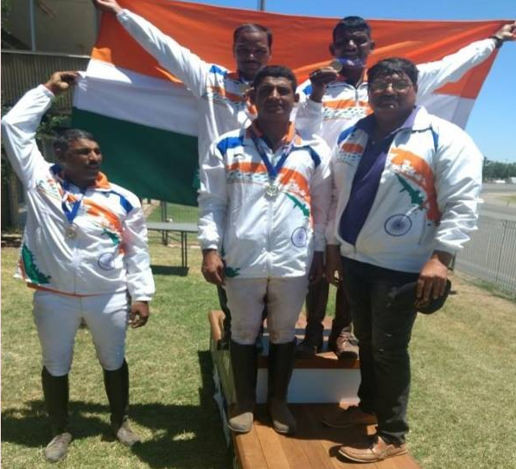
CDI-Y-2017 AT TAIPEI (TAIWAN)

- Invitation recd from Chinese Taipei Equestrian Federation for participation of Indian young rider dressage (on borrowed horses) scheduled wef 05 to 08 Nov 2017 at Hannover Riding Centre, Taipei, Chinese Taipei.
- Sports Ministry / Govt of India had given approval under “AT COST TO THE GOVERNMENT”
- Based on the results of JNEC/ FEI WDC 2016, MS SAMARAH K MALANEY was selected by the selection committee to represent the country
- Official : Col Dushyant Bali
5. Result : 10th Position

CSIJ-B-2017 AT TAIPEI (TAIWAN)
- Invitation recd from Chinese Taipei Equestrian Federation for participation of Indian junior rider show jumping (on borrowed horses) scheduled wef 05 to 08 Nov 2017 at Hannover Riding Centre, Taipei, Chinese Taipei.

- Sports Ministry / Govt of India had given approval under “AT COST TO THE GOVERNMENT”.

- Based on the results of JNEC 2016, MR JIBRAN KHAN was selected by the selection committee to represent the country

- Official : Comdt Naresh Tehlan

- No of Participants : 24

- Result : 07th Position

CSIJ-B-2017 2ND ASIAN JUMPING CHAMPIONSHIP 2017 AT HONG KONG

- Invitation recd from Hong Kong Equestrian Federation for participation of one rider (cat age of 14-18 yrs old) in Show Jumping (on borrowed horses) scheduled wef 01 Dec to 03 Dec 2017 at Beas River Equestrian Centre, Sheung Shui, Hong Kong.

- Based on the result of JNEC Ms Mahira Furniturewala was selected to represent the country

- Official/Coach cum Manager - Mr Yashan Khambata

- Results : 07th Position

FEI WORLD JUMPING CHALLENGE FINAL 2018

- Official invitation received for FEI World Challenge Final 2018

- Venue : Tashkent, Uzbekistan

- Duration : 05-09 Sep 2018

- Atheltes :-

- Lt Col Sandeep Dewan (Retd)

- Mr Nitin Gupta

- Sanction : Full cost to Govt.

- Results : Lt Col Sandeep Dewan (Retd) - 9th Position
Mr Nitin Gupta - Did not qualify for the final

ASIAN GAMES 2018

Discipline | Medal | Name of Rider
Eventing | Silver (Individual) | Fouaad Mirza
Eventing | Silver (Team) | Fouaad Mirza
Eventing | Silver (Team) | Maj Ashish Malik
Eventing | Silver (Team) | Swr Jitender Singh
Eventing | Silver (Team) | Swr Rakesh Kumar

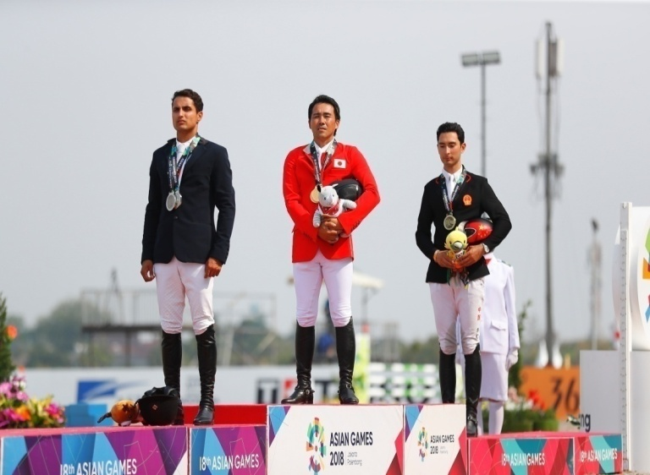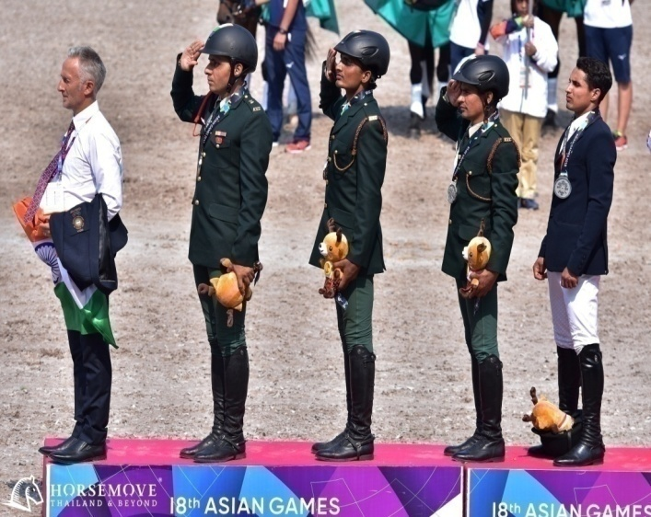

Appendix ‘B’
SECRETARIAT FUNCTIONING
- Min 35 to 40 events are being conducted every year since 2015 as against just 12 to 15 events during previous years.

- Each event has to go through the following activities :-

- Approval OF EC/GA.
- Govt sanction.
- Prospectus approval.
- Prospectus upload in website.
- Jury detailment.
- TD sanction.
- Intimation of TD to Jury.
- Foreign jury detailment.
- calendar approval of FEI.
- Foreign jury itinerary.
- Foreign jury hotel booking.
- Foreign jury invitation.
- Foreign jury MI clearance.
- Fwd of MI to OC.
- VSM/Vet delegate detailment.
- Medal/Rosetts preparation.
- Facebook upload.
- Conduct of events.
- Result upload on Website.
- Certificates.

Appendix ‘C’
FEI WDC RIDER POINTS

EVENTS | 1ST | 2ND | 3RD | 4TH | 5TH | 6TH
NEC Intermediate-I | 20 | 18 | 16 | 14 | 12 | 10
NEC/ FEI World Challenge Prix St George | 16 | 14 | 12 | 10 | 8 | 6
NEC/FEI World Challenge Advance/Senior II | 14 | 12 | 10 | 8 | 6 | 4
Advance Medium/Senior I | 12 | 10 | 8 | 6 | 4 | 2
International Dressage on Borrowed Horses in India and abroad | 12 | 10 | 8 | 6 | 4 | 2

Note :-

- FEI World Challenge Advance and Advance Medium should be deleted.

- Senior I & Senior II should be added.

Appendix ‘D’

REDUCTION OF MEMBERSHIP FEE

- During AGM 2017 held on 27 Aug 2017 a point was raised by the house for reduction in membership fee.

- New membership fee proposed is as under :-

Type of Membership | Earlier | Existing | Proposed
Life Membership | 5000/- | 15,000/- | 7,000/-
Indl MEMBERSHIP | 300/- | 1,000/- | 1,000/-
Club/unit Membership | 1000/- | 5,000/- | 3,000/-
Association Membership | 2000/- | 8,000/- | 8,000/-

Appendix ‘E’
REGIONAL EQUESTRIAN LEAGUE (REL) GUIDELINES:
SHOW JUMPING, TENT PEGGING AND JNEC

Introduction

- Unlike other sports, equestrian field does not have Distt / State level championship due to lack of infrastructure, as a result of which many a time naïve horse-rider combinations have participated in National championships thereby diluting the sanctity of the National Level competition. REL concept has been developed to offer more opportunities to riders to participate in various competition within the region and qualify themselves to compete at National level.

Objective

- Promote Equestrian sports at Regional Level by empowering Regional Members.

- Promote more civilian organizing committee & civil venues to hold equestrian events.

- Popularize the sports throughout the country.

- Offer more competitions to horse-rider combinations in their own region thereby reducing the burden of transportation cost.

- Select horse rider combination worthy of participation at National level.

Concept

- To achieve the above objectives, holding of Equestrian competitions at regional level is proposed on the lines of World Challenge Jumping (WCJ) for which the country will be divided into following zones: -

    - North Zone (J&K, Himachal Pradesh, Punjab, Haryana and Union Territories of Chandigarh and Delhi).

    - East Zone (West Bengal, Bihar, Jharkhand and Orissa).

    - West Zone (Maharashtra, Goa, Gujarat, and Rajasthan).

    - South Zone (Tamil Nadu, Kerala, Karnataka, Andhra Pradesh, Telengana and Puducherry).

    - Central Zone (UP, Madhya Pradesh, Chhattisgarh and Uttrakhand).

    - North East Zone (Assam, Manipur, Nagaland, Sikkim, Arunachal Pradesh, Tripura, Meghalaya and Mizoram).

- Respective Zonal Members shall be responsible to organize regional championships.

-2-

- One EFI Rep (CD/Jury as per the request of OC) shall be detailed for each horse show to ensure that the desired levels are not diluted.

- Course plans for show jumping will be provided by EFI to be followed at all venues so as to have uniformity in level of competition for all and for Dressage and Tent Pegging uniform standards as per tech guidelines of EFI will be followed.

- The MER as per appx will be followed and rider must participate at minimum of two venues and achieve 02 MERs to be eligible to participate in NEC/ JNEC.

- To qualify for the Nationals, rider may participate in any number of competitions being held at various venues all over the country to achieve the desired MER.

- At present REL is introduced only for the following categories:

  - Seniors: Only in Show Jumping (Novice & Grade III) and Tent Pegging.

  - Juniors: Only in Show Jumping and Dressage (Junior, Children I & Children II).

- Rest of the categories except mentioned above will not be included in REL and the riders can participate directly in NEC/JNEC as applicable.

- Expenditure on transportation, accommodation & hospitalities of officials shall be borne by the organizers.

- Organizers to use their own infrastructure.

- Course Plans and Dressage tests for these categories are attached as appx ‘A’ to ‘F’

Incentive

- Incentive will be given by EFI to a club once in a calendar year.
Rs 50,000/- will be given if participation of over 25 riders and Rs 25,000/- to be given for less than 25 riders.

Procedure

- Interested organizers may forward their bids to EFI after due consultation with Regional Member regarding the exact dates of event. The recommendation of Member Region is mandatory. On receipt of the bids the same will be evaluated by the Bid Evaluation Committee for allotment of events. On allotment of the event the same will be included in the EFI Calendar for 2018-19 which will facilitate all horse-rider combinations to plan their move to various venues and participate to achieve MER to qualify for NEC.

- Organizers will have to deposit a refundable security of Rs 50,000/- alongwith bid which will be refunded with incentive mentioned in Para 15 on successful completion of event. In case of non completion of event as per EFI guidelines security deposit will not be returned.

MER REL

Ser No | Discipline | MER | No of MERs required | Remarks
1. | Show Jumping
1. | Seniors | Max 08 penalties excluding time penalties in 01 round | 02 | Same horse-rider combination needs to achieve MER
1. | Juniors | Max 08 penalties excluding time penalties in 01 round | 02 | MER is only for the rider, not for the combination
1. | Children I | Max 08 penalties excluding time penalties in 01 round | 02 | MER is only for the rider, not for the combination
1. | Children II | Max 08 penalties excluding time penalties in 01 round | 02 | MER is only for the rider, not for the combination
2. | Dressage
2. | Juniors | Min 57% score in REL | 02 | MER is only for the rider, not for the combination
2. | Children I | Min 57% score in REL | 02 | MER is only for the rider, not for the combination
2. | Children II | Min 57% score in REL | 02 | MER is only for the rider, not for the combination
3. | Tent Pegging | - Three run with Lance  - Two run on 6cm Peg  - One run on 4cm Peg  - Three run with Sword  - Two run on 6cm peg.  - One run on 4cm peg  - Min score of 24 excluding time penalties | 02 | Same horse-rider combination needs to achieve two MER

REGIONAL EQUESTRIAN LEAGUE 2018-19 : GRADE III & NOVICE
Gde III – 7.60m
Novice -7.50m
Gde III – 7.70m
Novice -7.60m
35m
24.50m
Gde III – 21.50m
Novice -21.00m
28m
28m
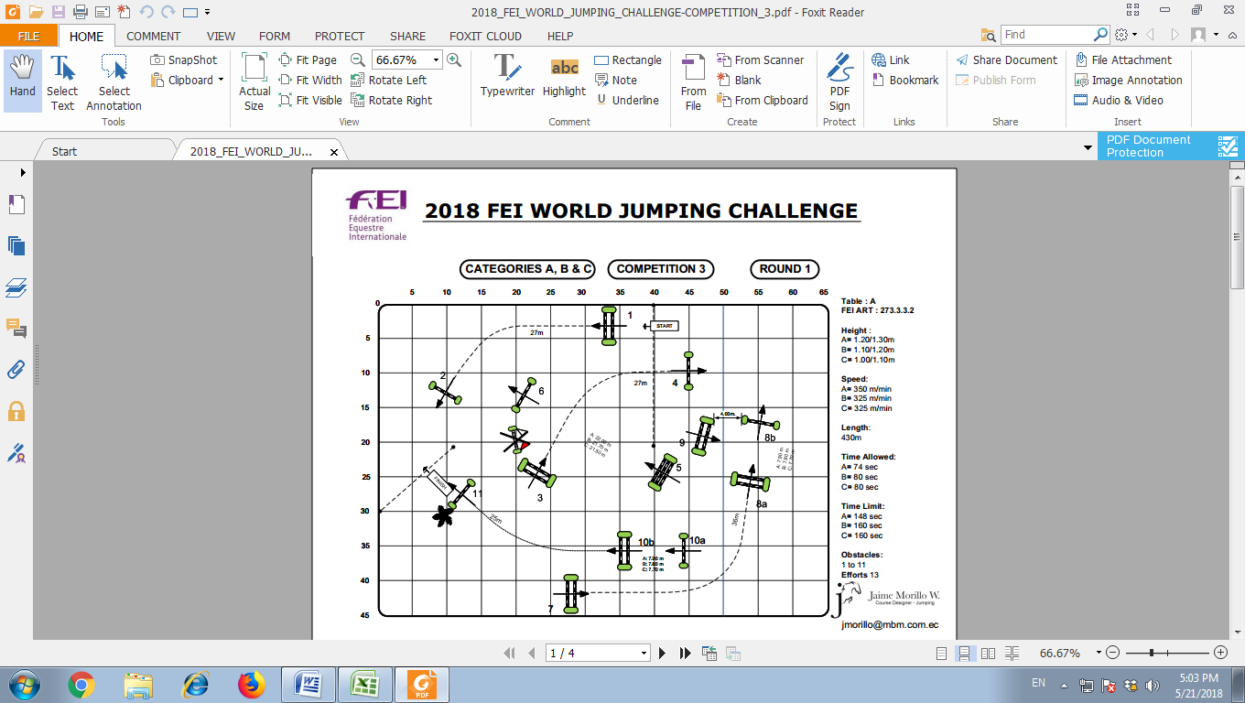
Table : A

Height :

Gde-III = 1.05/1.20m
Novice = 0.95/1.10m

Speed : 325 m/min

Length : 430m

Time Allowed : 80 Sec

Time Limit : 160 Sec

Obstacles :

1 to 11
Efforts 13

REGIONAL EQUESTRIAN LEAGUE 2018-19
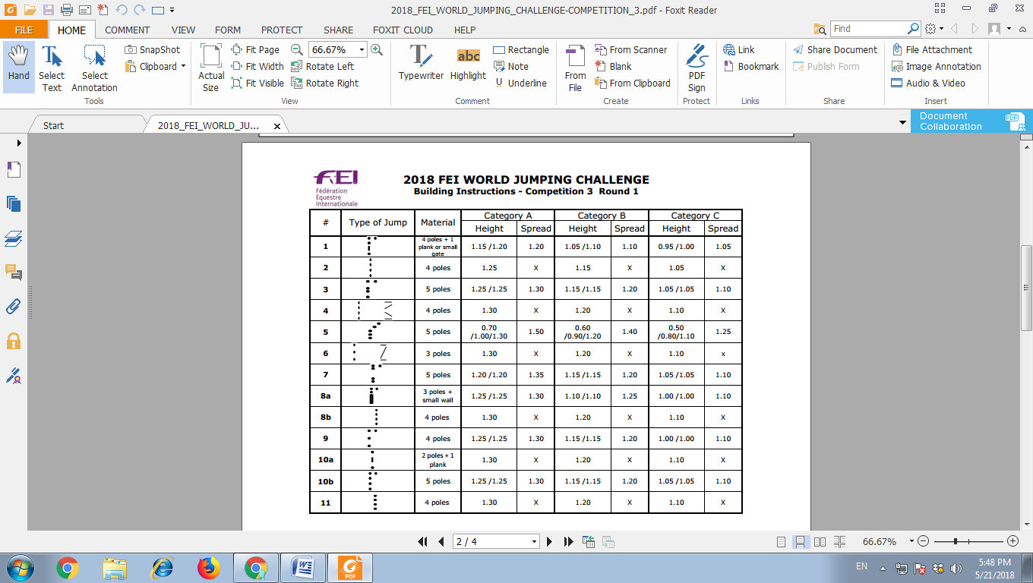 | Grade-III |  | Novice
 | Height | Spread | Height | Spread
 | 1.05/1.10 | 1.10 | 0.95/1.00 | 1.05
 | 1.15 | X | 1.05 | X
 | 1.15/1.15 | 1.20 | 1.05/1.05 | 1.10
 | 1.20 | X | 1.10 | X
 | 0.60/0.90/  1.20 | 1.40 | 0.50/0.80 /1.10 | 1.25
 | 1.20 | X | 1.10 | X
 | 1.15/1.15 | 1.20 | 1.05/1.05 | 1.10
 | 1.10/1.10 | 1.25 | 1.00/1.00 | 1.10
 | 1.20 | X | 1.10 | X
 | 1.15/1.15 | 1.20 | 1.00/1.00 | 1.10
 | 1.20 | X | 1.10 | X
 | 1.15/1.15 | 1.20 | 1.05/1.05 | 1.10
 | 1.20 | X | 1.10 | X
REGIONAL EQUESTRIAN LEAGUE 2018 : JNEC
Jump | Type | Junior |  | Children-I |  | Children-II |  | Obstacle’s | Materials
Jump | Type | Height | Spread | Height | Spread | Height | Spread | Obstacle’s | Materials
1 | Oxer | 0.90x0.95m | 1.00m | 0.70m | 0.95m | 0.60m | 0.90m | 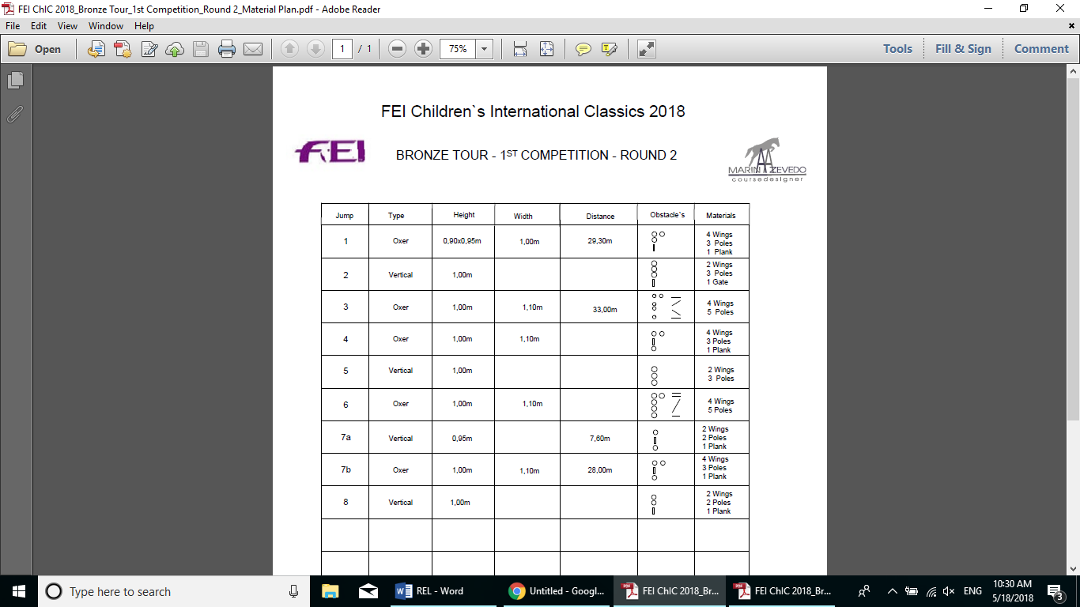
2 | Vertical | 0.95m | X | 0.75m | X | 0.65m | X
3 | Oxer | 0.95m | 1.10m | 0.80m | 1.00m | 0.70m | 0.90m
4 | Oxer | 1.00m | 1.10m | 0.85m | 1.00m | 0.75m | 0.90m
5 | Vertical | 1.00m | X | 0.85m | X | 0.75m | X
6 | Oxer | 1.00m | 1.10m | 0.85m | 1.00m | 0.75m | 0.90m
7a | Vertical | 0.95m | X | 0.85m | X | 0.75m | X
7b | Oxer | 1.00m | 1.10m | 0.85m | 1.00m | 0.75m | 0.90m
8 | Vertical | 1.00m | X | 0.85m | X | 0.75m | X

REGIONAL EQUESTRIAN LEAGUE 2018-19: JNEC
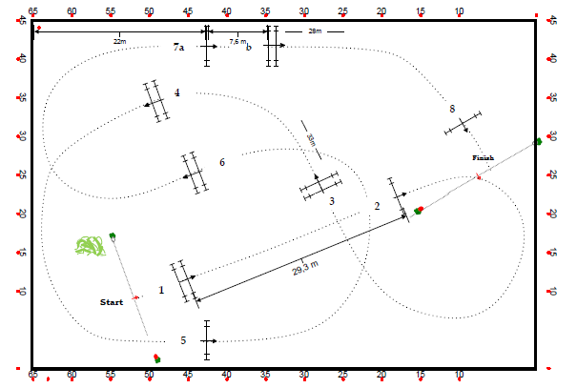
Table : A

Height :

Junior = 0.90/1.00m
Ch-I = 0.70/0.85m
Ch-II = 0.60/0.75m

Speed : 325m/min

Length : 320m

Time Allowed : 59 Sec

Time Limit : 118 Sec

Obstacles : 8
Efforts : 9

b

7.30m
28.0m
32m

Appendix ‘F’

REGIONAL EQUESTRIAN LEAGUE (REL) GUIDELINES:
SHOW JUMPING, TENT PEGGING AND JNEC

Introduction

- Unlike other sports, equestrian field does not have Distt / State level championship due to lack of infrastructure, as a result of which many a time naïve horse-rider combinations have participated in National championships thereby diluting the sanctity of the National Level competition. REL concept has been developed to offer more opportunities to riders to participate in various competition within the region and qualify themselves to compete at National level.

Objective

- Promote Equestrian sports at Regional Level by empowering Regional Members.

- Promote more civilian organizing committee & civil venues to hold equestrian events.

- Popularize the sports throughout the country.

- Offer more competitions to horse-rider combinations in their own region thereby reducing the burden of transportation cost.

- Select horse rider combination worthy of participation at National level.

Concept

- To achieve the above objectives, holding of Equestrian competitions at regional level is proposed on the lines of World Challenge Jumping (WCJ) for which the country will be divided into following zones: -

    - North Zone (J&K, Himachal Pradesh, Punjab, Haryana and Union Territories of Chandigarh and Delhi).

    - East Zone (West Bengal, Bihar, Jharkhand and Orissa).

    - West Zone (Maharashtra, Goa, Gujarat, and Rajasthan).

    - South Zone (Tamil Nadu, Kerala, Karnataka, Andhra Pradesh, Telengana and Puducherry).

    - Central Zone (UP, Madhya Pradesh, Chhattisgarh and Uttrakhand).

    - North East Zone (Assam, Manipur, Nagaland, Sikkim, Arunachal Pradesh, Tripura, Meghalaya and Mizoram).

- Respective Zonal Members shall be responsible to organize regional championships.

-2-

- One EFI Rep (CD/Jury as per the request of OC) shall be detailed for each horse show to ensure that the desired levels are not diluted.

- Course plans for show jumping will be provided by EFI to be followed at all venues so as to have uniformity in level of competition for all and for Dressage and Tent Pegging uniform standards as per tech guidelines of EFI will be followed.

- The MER as per appx will be followed and rider must participate at minimum of two RELs and achieve 02 MERs to be eligible to participate in NEC/ JNEC.

- To qualify for the Nationals, rider may participate in any number of competitions being held at various venues all over the country to achieve the desired MER.

- At present REL is introduced only for the following categories:

  - Seniors: Only in Show Jumping (Novice & Grade III) and Tent Pegging.

  - Juniors: Only in Show Jumping and Dressage (Junior, Children I & Children II).

- Rest of the categories except mentioned above will not be included in REL and the riders can participate directly in NEC/JNEC as applicable.

- Expenditure on transportation, accommodation & hospitalities of officials shall be borne by the organizers.

- Organizers to use their own infrastructure.

- Course Plans and Dressage tests for these categories are attached as appx ‘A’ to ‘F’

Incentive

- Incentive will be given by EFI to a club once in a calendar year.
Rs 50,000/- will be given if participation of over 25 riders and Rs 25,000/- to be given for less than 25 riders.

Procedure

- Interested organizers may forward their bids to EFI after due consultation with Regional Member regarding the exact dates of event. The recommendation of Member Region is mandatory. On receipt of the bids the same will be evaluated by the Bid Evaluation Committee for allotment of events. On allotment of the event the same will be included in the EFI Calendar for 2018-19 which will facilitate all horse-rider combinations to plan their move to various venues and participate to achieve MER to qualify for NEC.

- Organizers will have to deposit a refundable security of Rs 50,000/- alongwith bid which will be refunded with incentive mentioned in Para 15 on successful completion of event. In case of non completion of event as per EFI guidelines security deposit will not be returned.

MER REL

Ser No | Discipline | MER | No of MERs required | Remarks
1. | Show Jumping
1. | Seniors | Max 08 penalties excluding time penalties in 01 round | 02 | Same horse-rider combination needs to achieve MER
1. | Juniors | Max 08 penalties excluding time penalties in 01 round | 02 | MER is only for the rider, not for the combination
1. | Children I | Max 08 penalties excluding time penalties in 01 round | 02 | MER is only for the rider, not for the combination
1. | Children II | Max 08 penalties excluding time penalties in 01 round | 02 | MER is only for the rider, not for the combination
2. | Dressage
2. | Juniors | Min 57% score in REL | 02 | MER is only for the rider, not for the combination
2. | Children I | Min 57% score in REL | 02 | MER is only for the rider, not for the combination
2. | Children II | Min 57% score in REL | 02 | MER is only for the rider, not for the combination
3. | Tent Pegging | - Three run with Lance  - Two run on 6cm Peg  - One run on 4cm Peg  - Three run with Sword  - Two run on 6cm peg.  - One run on 4cm peg  - Min score of 24 excluding time penalties (However the horse needs to gallop between start line to finish line) | 02 | Same horse-rider combination is not mandatory however two riders cannot ride the same horse in the same REL.

REGIONAL EQUESTRIAN LEAGUE 2018-19 : GRADE III & NOVICE
Gde III – 7.60m
Novice -7.50m
Gde III – 7.70m
Novice -7.60m
35m
24.50m
Gde III – 21.50m
Novice -21.00m
28m
28m
Table : A

Height :

Gde-III = 1.05/1.20m
Novice = 0.95/1.10m

Speed : 325 m/min

Length : 430m

Time Allowed : 80 Sec

Time Limit : 160 Sec

Obstacles :

1 to 11
Efforts 13

REGIONAL EQUESTRIAN LEAGUE 2018-19
 | Grade-III |  | Novice
 | Height | Spread | Height | Spread
 | 1.05/1.10 | 1.10 | 0.95/1.00 | 1.05
 | 1.15 | X | 1.05 | X
 | 1.15/1.15 | 1.20 | 1.05/1.05 | 1.10
 | 1.20 | X | 1.10 | X
 | 0.60/0.90/  1.20 | 1.40 | 0.50/0.80 /1.10 | 1.25
 | 1.20 | X | 1.10 | X
 | 1.15/1.15 | 1.20 | 1.05/1.05 | 1.10
 | 1.10/1.10 | 1.25 | 1.00/1.00 | 1.10
 | 1.20 | X | 1.10 | X
 | 1.15/1.15 | 1.20 | 1.00/1.00 | 1.10
 | 1.20 | X | 1.10 | X
 | 1.15/1.15 | 1.20 | 1.05/1.05 | 1.10
 | 1.20 | X | 1.10 | X
REGIONAL EQUESTRIAN LEAGUE 2018 : JNEC
Jump | Type | Junior |  | Children-I |  | Children-II |  | Obstacle’s | Materials
Jump | Type | Height | Spread | Height | Spread | Height | Spread | Obstacle’s | Materials
1 | Oxer | 0.90x0.95m | 1.00m | 0.70m | 0.95m | 0.60m | 0.90m
2 | Vertical | 0.95m | X | 0.75m | X | 0.65m | X
3 | Oxer | 0.95m | 1.10m | 0.80m | 1.00m | 0.70m | 0.90m
4 | Oxer | 1.00m | 1.10m | 0.85m | 1.00m | 0.75m | 0.90m
5 | Vertical | 1.00m | X | 0.85m | X | 0.75m | X
6 | Oxer | 1.00m | 1.10m | 0.85m | 1.00m | 0.75m | 0.90m
7a | Vertical | 0.95m | X | 0.85m | X | 0.75m | X
7b | Oxer | 1.00m | 1.10m | 0.85m | 1.00m | 0.75m | 0.90m
8 | Vertical | 1.00m | X | 0.85m | X | 0.75m | X

REGIONAL EQUESTRIAN LEAGUE 2018-19: JNEC
Table : A

Height :

Junior = 0.90/1.00m
Ch-I = 0.70/0.85m
Ch-II = 0.60/0.75m

Speed : 325m/min

Length : 320m

Time Allowed : 59 Sec

Time Limit : 118 Sec

Obstacles : 8
Efforts : 9

b

7.30m
28.0m
32m

Appendix ‘H’

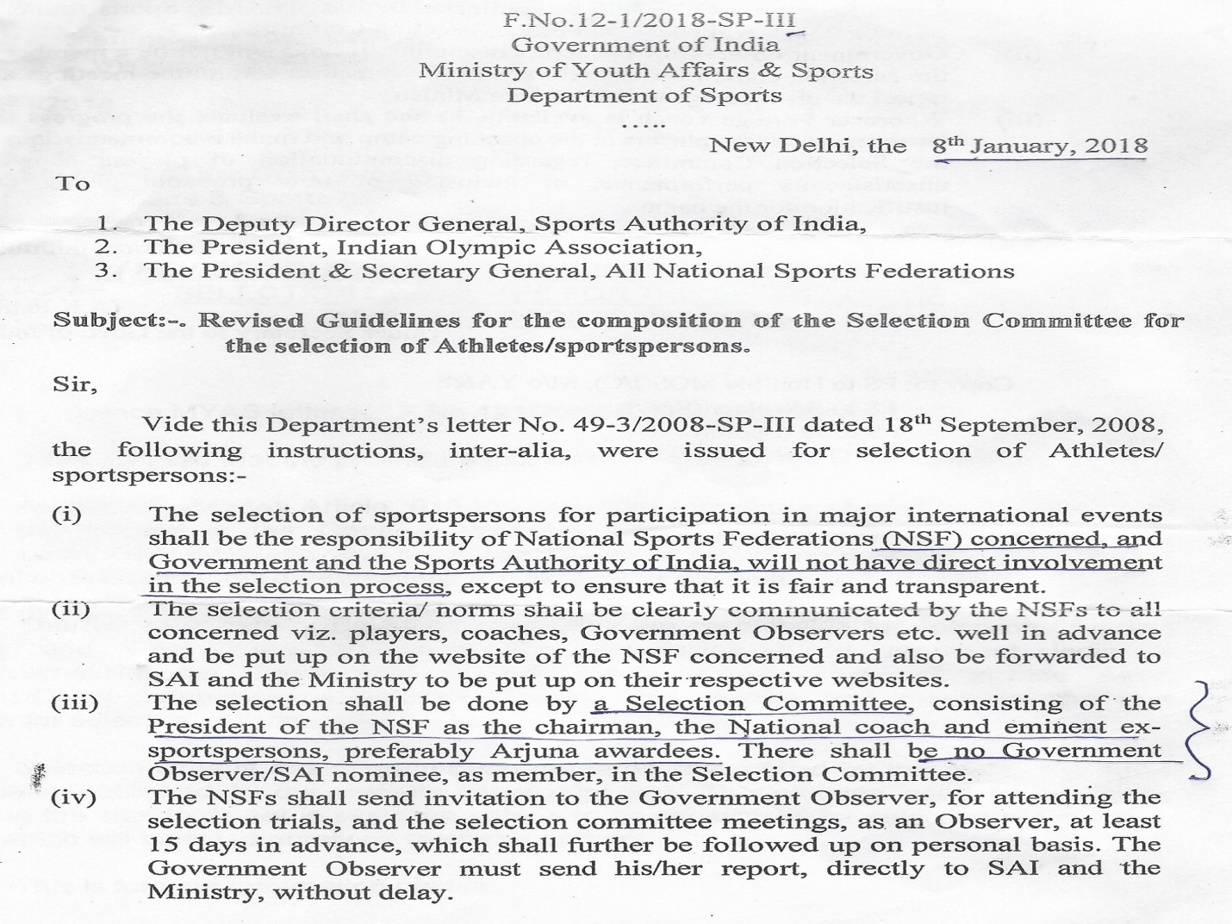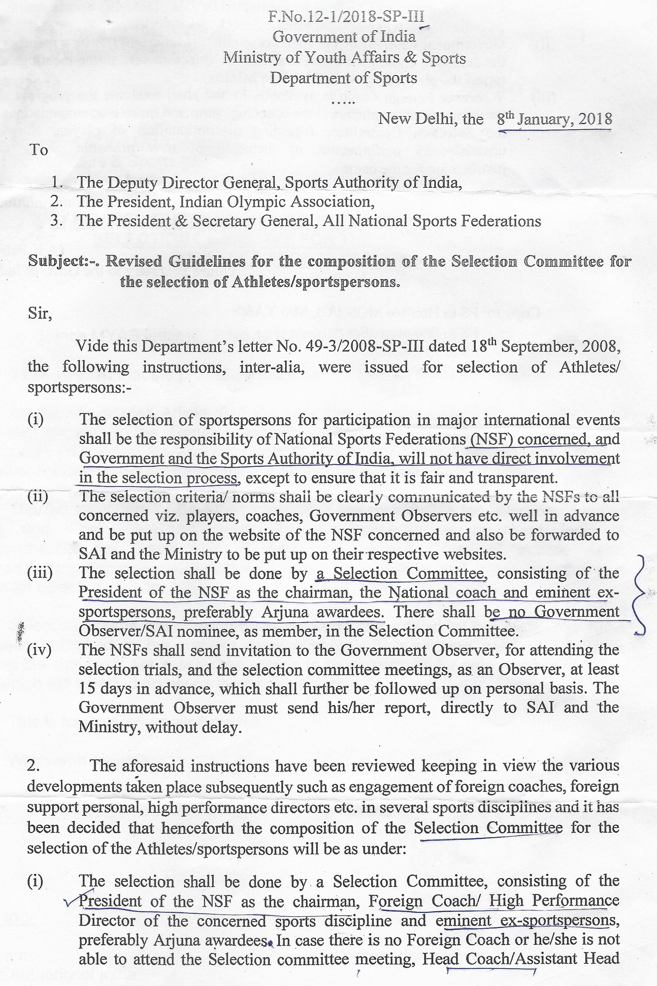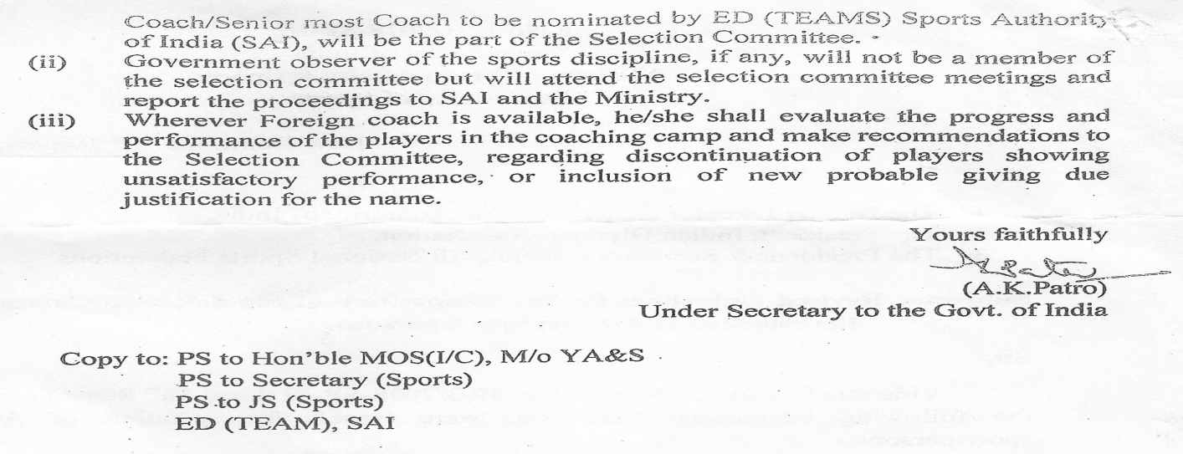
Appendix ‘J’

FEI SOLIDARITY COACHING CAMP : EVENTING AND SHOW JUMPING

1. FEI Solidarity Eventing Coaching Camps :-

Venue | RVC Centre and College, Meerut | Army Equestrian Centre, Delhi Cantt
Duration | 09 -15 Oct 2017 | 20-30 Nov 2017
Coach | Rudolph Scherer | Rudolph Scherer
Participants | 16 | 14

2. FEI Solidarity Show Jumping Coaching Camps :-

Venue | Army Equestrian Centre, Delhi Cantt | RVC Centre and College, Meerut
Duration | 08-14 Jul 2018 | 16-25 Jul 2018
Coach | John Steels | John Steels
Participants | 23 | 24

Appendix ‘K’

ACTC COACHING CAMP : SHOW JUMPING & Dressage

1. ACTC Coaching Camps :-

Coaching Camp | Show Jumping | Dressage
Venue | Embassy International Riding School, Bangalore | AEN c/o RVC Centre and College, Meerut
Duration | 16-25 Aug 2018 | 01-07 Sep 2018
Coach | John Steels | Samantha York
Participants | 20 | 20+4

Appendix ‘L’

DETAILMENT OF INDIAN OFFICIAL AS MEMBER OF JURY/ TD IN INTERNATIONAL EVENTS

Name of Official | Detailed as | Event
COL SS Ahlawat (Retd) | Assistant Steward | Asian Games C1* AT Jakarta, Indonesia from 18 Aug to 02 Sep 18
COL SS Ahlawat (Retd) | Ground Jury President | CIC2* Eventing at Strzegom ,Poland from 06-08 Apr 18
COL SS Ahlawat (Retd) | Ground Jury President | CCI1* Eventing at Tartus, France from 29 Mar to 02 Apr 18
Col PP Singh (Retd) | Assistant Technical Delegate | Asian Games C1* AT Jakarta, Indonesia from 18 Aug to 02 Sep 18
Col PP Singh (Retd) | Technical Delegate | CCI2* & CIC2* Eventing at Strezegom, Poland from 11-14 Oct 18
Col PP Singh (Retd) | Technical Delegate | CCI* & CIC1* Eventing at Ballindenisk, Ireland from 19-23 Sep 18
Col PP Singh (Retd) | Technical Delegate | CCI1* Eventing at Pompadour, France from 15-17 Jun 18
Col PP Singh (Retd) | Assistant Technical Delegate | CCI1* & CIC1* Eventing at Jardy, France from 12-16 Jul 18
Col Sunil Shivdas | Ground Jury Member | CDI3*, CDIJ, CDIU25, CDIY Dressage at Brisbane QLD, Australia from 18-21 Jul 18
Col Sunil Shivdas | Ground Jury Member | CDIAm (A), CDIJ, CDIOJ, CDIOY, CDIP Dressage at Uggerhalne, Denmark from 23-27 May 18
Col Sunil Shivdas | Ground Jury Member | CDI3*, CDICh-A, CDIJ, CDIP, CDIY at Abrantes, Porland from 23-25 Mar 18
Col Sunil Shivdas | Ground Jury Member | CDI1*, CDI3* at Wellington FL, USA from 14-18 Mar 18
Col RK Dahiya | Technical Delegate | CCI1*, CCI2*, CIC2* at Dubrava, Russia from 05-09 Sep 18

Appendix ‘M’

STATE OF FUNDS AS ON 31 AUG 2018

1. Cash in Hand - Rs 23,611.00

2. Cash in Bank - Rs 39,01,355.85

3. Total FD - Rs 4,68,51,949.38

Appendix ‘N’
PROPOSED BUDGET FOR 2018-2019

S No | Head | Budget Allotted for  2017-2018 | Expenditure  for 2017-2018 | Proposed  expenditure  for 2018-19 | Remarks
1. | Establishment incl  salary and allowances (incl PF) to office staff | 8,50,000/- | 8,95,204/- | 10,00,000/- | Asst Secy/Office Messenger and Data Entry Operator (expdr increased due to increase in DA/Salary). The salary of Asst Secy is being claimed from SAI on quarterly basis.
2. | Postage stamps and courier | 30,000/- | 21,742/- | 30,000/-
3. | Office Maintenance/Rent | 1,50,000/- | 1,66,600/- | 1,70.000/-
4. | Legal & Professional Expense | 1,50,000/- | 1,05,127/- | 25,00,000/- | Expdr being incurred for Court cases pertaining to Ms Angad Sahlot, Ms Neesha Khatau and Mr Balaji Vijay Shankar
5. | Telephone/Internet/Fax/ Website | 2,50,000/- | 3,90.051/- | 3,00,000/- | Addl expdr for Rs 1,13,016/- has been incurred in connection with trg for NF IT platform workshop wef 24 and 25 Oct 2017 held at Lausanne (Switzerland) the same was attended by project manager
6. | Payment of Subscription to FEI/AEF/ITPF/IOA | 2,50,000/- | 3,14,752/- | 3,50,000/- | Incl amount paid for registration fee, annual subscription, calendar fee etc
7. | Annual General Assembly FEI/AEF | 4,00,000/- | 5,66,125/- | 5,60,000/-
8. | International Events in India and Abroad, Foreign coaches, foreign competition, conduct of Trials coaching, Training and Asian Games expdr | 60,00,000/- | 43,20,563/- | 65,00,000/- | Additional budget required for 18th Asian Games held at Jakarta wef 26 Aug 18 to 02 Sep 18 (Horse feed, local tptn of horse, air tickets of grooms/officials etc)  Rs 21,85,012/- claimed for 04 trails with SAI and 1st trails amt Rs 5,55,806/- has been recd out of 04 trails, remaining 03 trails will be recd shortly  Show Jumping coaching camp claim for Rs 6,16,372/- recd from SAI and Travel expense of Ms Agnieszka Jolanta in connection with FEI WDC of Rs 1,13,855/- recd from FEI
9. | Electricity & water charges, etc | Nil | - | -

2

S No | Head | Budget Allotted for  2017-2018 | Expenditure  for 2017-2018 | Proposed  expenditure  for 2018-19 | Remarks
10. | National events  (Medals, Rosettes, Momentos & Certificates) | 3,00,000/- | 93,506/- | 5,00,000/- | Two national events not conducted due to glanders, hence the amt could not be utilized fully
11. | Travel expenses of officials detailed by EFI | 1,50,000/- | 1,07,350/- | 1,50,000/-
12. | Publicity & Media | 1,00,000/- | 74,970/- | 2,00,000/-
13. | Stationery and Printing | 2,50,000/- | 2,84,733/- | 2,50,000/- | Printing of New Statutes, New Horse Pass Ports and round regn tag sets (Rs 1,61,419/-)
14. | Visit EFI Officials abroad | 2,50,334/- | 4,33,263/- | 2,50.000/- | Addl expdr for visit of Col HR Sunil, SC member at Le Puget France (Rs 1,49,992/-) and air fare of Col PP Sing (Retd) visit at France (Rs 51098/-)
15. | Financial Assistance for REL | 5,00,000/- | 6,75,000/- | 10,00,000/- | As per para 5.19 of minutes of Annual General Body Meeting 2016 a new scheme/policy of incentive of Rs 50,000/- (Rupees fifty thousand only) to the units/organisations conducting REL has been introduced with effect from Equestrian Calendar 2016-17
16. | Financial Assistance to Army Units for organising events | 13,00,000/- | 9,00,000/- | 13,00,000/- | As per para 7.14 of EC Meeting 03 Nov 2016 a new policy has been introduced to give financial assistance to Army units for organising NEC/JNEC, CIC*/CCI of various disciplines with imdt effect.
17. | Miscellaneous Expenditure (AGM / ECM, repair & maintenance of computer & other expenditure) | 5,00,000/- | 5,71,296/- | 6,00,000/-
18 | Financial Assistance to the officials who are detailed by the EFI to attend any course at abroad | 2,00,000/- | 50,000/- | 2,00,000/- | As per para 5.21 of minutes of Annual General Body Meeting 2016 a new scheme/policy of financial assistance of Rs 25,000/- (Rupees twenty five thousand only) to the officials who are detailed by the EFI to attend any course abroad was approved to be made effective with effect from 01 Apr 2016.
3

S No | Head | Budget Allotted for  2017-2018 | Expenditure  for 2017-2018 | Proposed  expenditure  for 2018-19 | Remarks
19. | Bal payment for 17th Asian Games | - | 16,07,930/- | - | Bal outstanding payment made to M/s Guido Klattee, Europe and RE Rogers India Pvt Ltd
20 | Payment for notice of demand under section 156 of the Income Tax Act 1961 | - | 14,74,250/- | - | Paid to Income tax department
Total |  | 1,16,30,334/- | 1,30,52,462/- | 1,58,60,000/-

Appendix ‘O’
EQUESTRIAN CALENDAR : 2018-19
S No | Tentative Dates | Discipline | Events | Venue | Organizer | Remarks
 | 04-05 Aug 2018 | REL all discp | NEC and JNEC REL | Bangalore | EIRS | REL
 | 18 Aug to02 Sep 2018 | All Discipline | 18th ASIAN GAMES JAKARTA(INDO) | Jakarta | AEF
 | 16-25 Aug 2018 | Jumping | Coaching Camp | Bangalore | EIRS
 | 01-10 Sep 2018 | Dressage | Coaching Camp | Meerut | RVC C&C
 | 11-14 Sep 2018 | Coach Trg | Coaching of Coaches | Meerut | RVC C&C
 | 15-16 Sep 2018 | REL all discp | NEC and JNEC REL | Chennai | Tamil Nadu Horse Riders Association | REL  Postponed  Ser No 24
 | 15-20 Sep 2018 | Dressage  All discipline REL | NEC 2017-2018 & REL | Meerut | AEN c/o RVC C&C | REL
 | 22-23 Sep 2018 | REL all discp | NEC and JNEC REL | Hyderabad | TSEA | REL
 | 29-30 Sep 2018 | REL all discp | NEC and JNEC REL | Bangalore | EIRS | REL
 | 28 Sep to 08 Oct 2018 | All discipline REL | Chinkara Horse Show & REL | Jaipur | 61 Cav | REL
 | 06-07 Oct 2018 | REL all discp | NEC and JNEC REL | Gurugram | Chetak Equestrian Horse Riding Club | REL
 | 09-11 Oct 2018 | Dressage (Junior) | 1st U-21 AEF Dressage Championship Zonal Qualifiers | Jaipur  & Chennai | 61 Cav & Chennai Equitation Centre
 | 10-25 Oct  2018 | All Discipline | AEC Pre Novice, Novice including CIC* & CCI* & REL | Jaipur | 61 Cav | REL
 | 12-14 Oct 2018 | REL all discp | NEC and JNEC REL | Shikhrapur | Ride to live academy | REL
 | 13-21 Oct 2018 | Coaching Camp | Coaching Camp for Children & Junior Rider Dressage | Jaipur | 61 Cav
 | 15-24 Oct 2018 | Tent Pegging | Coaching Camp | Delhi | APRC
 | 20-21 Oct 2018 | REL all discp | NEC and JNEC REL | Hyderabad | TSEA | REL
 | 20-21 Oct 2018 | REL all discp | NEC and JNEC REL | Bangalore | EIRS | REL
 | 25 Oct 2018 | REL Tent Pegging | NEC | Jalandar Cantt | 7th Battalion Punjab Armed Police
 | 26-28 Oct 2018 | Endurance | NEC Endurance 40 Km | Jaipur | Sagar Equestrian Sports Academy
 | 03-04 Nov 2018 | Dressage & REL all discp | FEI World Challenge Dressage & REL | Delhi | APRC | Judges clinic & REL

2
S No | Tentative Dates | Discipline | Events | Venue | Organizer | Remarks
 | 05-06 Nov 2018 | Dressage & REL all discp | FEI World Challenge Dressage & REL | Bangalore | ASC C & C | REL
 | 03-11 Nov 2018 | Eventing | Coaching Camp | Delhi | 61 CAV/APRC
 | 10-11 Nov 2018 | REL all discp | NEC and JNEC REL | Chennai | Tamil Nadu Horse Riders Association | REL
 | 16-18 Nov 2018 | REL all discp | NEC and JNEC REL | Bondshi | Ride to live academy | REL
 | 17-22 Nov 2018 | Jumping | NEC 2017-2018 & CSI1* | Bangalore | EIRS | REL
 | 17-18 Nov 2018 | Jumping | FEI Children’s International Classics (Silver/Bronze) tour * REL | BHOPAL | MPSEA | REL
 | TBD | All Discipline (REL) | Southern Star Horse Show and REL & International Tent Pegging | Pune | Southern Command | REL
 | 24 -25 Nov 2018 | REL all discp | NEC and JNEC REL | Hyderabad | TSEA | REL
 | 29 Nov -02 Dec and  08-09 Dec 2018 | Jumping | FEI World Challenge Jumping Cat-A,B,C-2018 & REL Judges Clinic Show Jumping | Bangalore | EIRS / ASC C&C | REL
 | 01-04 Dec 2018 & 10-11 Dec 2018 | Jumping | FEI World Challenge Jumping Cat-A,B,C-2018 & REL Judges Clinic Show Jumping | Delhi | APRC | REL
 | 06-08 Dec 2018 | REL | Regional Equestrian League | Gurgaon | Equestrian Sports Academy, Gurgaon | REL
 | 10-16 Dec 2018 | Tent Pegging | REL followed by NEC | Delhi | Equestrian Sports Academy, Gurgaon | NEC Tent Pegging & REL
 | 10-19 Dec 2018 | Show Jumping | Coaching Camp for Children & Junior Rider Show Jumping | Kolkata | Tollygunge Club
 | 20-21 Dec 2018 | REL (JNEC) & All India Prelim | REL | Kolkata | Tollygunge Club | REL

3
S No | Tentative Dates | Discipline | Events | Venue | Organizer | Remarks
 | 22-30 Dec 2018 | All Discipline | Junior National Equestrian Championship | Kolkata | Tollygunge Club
 | 01-07 Jan 2019 | Dressage | Coaching Camp | Delhi | APRC/61 CAV
 | 08-11 Jan 2019 | Dressage | NEC 2019 | Delhi | APRC/61 CAV
 | 13-23 Jan 2019 | Eventing | Coaching Camp | Meerut | AEN c/o RVC C&C
 | 27 Jan – 07 Feb 2019 | Eventing/Jumping  REL | Eventing all grades Pre Novice, Novice, CI*, CI**, REL | Meerut | AEN c/o RVC C&C | REL
 | 05-15 Feb 2019 | Jumping | Coaching Camp | Meerut | AEN c/o RVC C&C
 | 16-23 Feb 2019 | Jumping | REL Show Jumping followed by NEC Show Jumping 2019 & CSI1* | Meerut | AEN c/o RVC C&C | REL
 | 05-14 Mar 2019 | Eventing | Coaching Camp | Bangalore | ASC C&C
 | 15-25Mar 2019 | Eventing | NEC- 2019, Bangalore Horse Show (Pre Novice, Novice, CI* & CI**) | Bangalore | ASC C&C
 | 28-31 Mar 2019 | Jumping | CSI (AM)/CSI B | Bangalore | EIRS
 | 05-15 Apr 2019 | All Discipline | Delhi Horse Show | Delhi | APRC/61 CAV

Appendix ‘P’

AMENDMENT IN STATUTES

Article | Para | Previous | Recommended
15 | 1 | The Selection Committee consisting of five members will be elected by the General Assembly. Only members who have won medals in any of the equestrian disciplines in the National Equestrian Championships are eligible. Their tenure will be of one/two/three/four years but must co-terminus with the Asian Games. The term will terminate at the AGM. Election succeeding the Asian Games. They can seek reelection for another term by simple majority. The President shall nominate the chairman of the Selection Committee to conduct the proceeding of the meeting. All proceedings will be recorded. The Secretary General can attend meetings but without voting rights and will record all proceedings and obtain signature of all attending Selection Committee members. Signed copies will be sent to all committee members by Secretary General within 10 days of convening a meeting. Copies will also be sent to all Executive Committee members and placed in the federation reading file. | The Selection Committee shall consists of  - President of the National Federation as the Chairman.  - National Coach if appointed.  - 05 members elected by the General Assembly.  Members who have won medals in National Equestrian Championship/ eminent sports person / Arjuna awardees are only eligible to be elected as Selection Committee members. Their tenure will be of one/two/three/four years and must be co-terminus with the Asian Games. The term will terminate at the AGM succeeding the Asian Games. The Secretary General can attend meetings without voting rights. All proceedings of the Selection Committee will be recorded and signed by members and further sent to EC members within 10 days for approval.  Note : Proposed change is in accordance to Mininstry of Youth and Sports letter No F.NO. 12-1/2018-SP-III dated 08 Jan 2018
023 | 15 | Add Para | The Secretary General is authorised to sign all legal documents on behalf of the Federation.

Appendix ‘Q’
ENDURANCE RULES
SER NO | PAGE NO | ARTICLE NO | PARA NO | EXISTING RULES | RECOMMENDED RULES | REMARKS
1 | 80 | 301 | 1-4 | CATEGORIES  1 NEC Pre Novice- All rides of 40 to 59 kms in one day.  2. NEC Novice- All rides of 60 to 79 km in one day.  3. NEC Intermediate- All rides of 80 to 119 km in one day.  4. NEC Advance- All rides above 120 km in one day or between 70 to 79 km in two days. | CATEGORIES:- The following categories will be applicable for Endurance of REL, NEC,CEN, CEI and CEIO events:-  1 Pre Novice- All rides of 40 to 59 kms in one day with maximum speed limit of 16 KPH.  2. Novice- All rides of 60 to 79 km in one day with maximum speed limit of 16 KPH.  3. Intermediate- All rides of 80 to 100 km in one day with maximum speed limit of 16 KPH.  4. One Star Endurance- All rides of 80 km to 119 km in one day.  5. Two Star Endurance- All rides of 120 km to 139 km in one day or of 70 km to 89 km per day over two days.  6. Three Star Endurance- All rides of 140 km to 160 km in one day, or 90 to100 km per day over 2 days, or 70 to 80 km per day over 3 days or more.  7. Four Star Endurance- Senior Championships of a minimum of 160 km in one day, Young Horse Championships for 7 year olds – maximum distance 130kms, Junior and Young Rider Championships of a minimum of 120 km, maximum of 130km in one day. | Categories made to facilitate progressive and systematic upgradation as per FEI guidelines while ensuring safety of horses and in best welfare of the sport.
2 | 80 | 302 | 1 & 2 | ELIGIBILITY OF RIDERS  1. Any rider 14 yrs and above can participate in senior rides.  2. Any person from the year in which he/she reaches his/her 14th birthday and who is duly authorised by his/her National Federation is eligible to take part in all Endurance Rides (CEIs, CEIOs and Championships – Senior and Junior/Young Rider). | ELIGIBILITY OF RIDERS:-  1. Any person from the year in which he/she reaches his/her 14th birthday and who is duly registered as rider with EFI is eligible to take part in all Endurance rides held under aegis of EFI and when registered with FEI can take part in all CEIs and CEIOs.  2. A trainer must have minimum age of 18 years and must be registered with EFI and FEI. | Due to change in FEI rules.

3 | 80 | 303 | 2,3 & 4 | RESTRICTION ON HORSES  2. Horses below 5 yrs of age cannot participate in National Endurance Championships. Horses must atleast 5 yrs old to qualify at Pre Novice level of competition.  3. Horses must be 6 yrs and above to participate in Novice and above levels.  4. A horse in the opinion of the Veterinary Commission has irregularity of gait consistently at walk or trot under all conditions and thought to cause pain or threaten the athletic future of the horse may be restricted from entering a competition. | ELIGIBILITY OF HORSES  2. Horses must be at least 5 years old to participate in Endurance Pre-Novices, Novice and Intermediate level.  3. For One star and above events as per Article 815.2 of FEI Endurance rules.  4. The Horse and Horse owner/Trainer (if Athlete and Trainer/Horse owner is not same person) must be registered and allotted EFI IDs before entering for any NEC/CEN/REL event and FEI IDs before entering his name for any CEI/CEIO event. The Athlete or the Horse owner to fill Novice Qualification eligibility form (Annex 2 of the FEI Endurance Rules) and submit to EFI through mail, which will further be filled in on the FEI online platform by EFI prior to the making the first entry for the Athlete/Horse in any CEI event.  Note:- Horse Log Book for all endurance must be maintained. The Log Book can be obtained from EFI. | EFI Guidelines synchronised with FEI rules
4 | 81 | 305 | 1&2 | UPGRADING PROCEDURES  1. Upgrading of horses will take place for horses that have competed in the NEC. Horses in the first four positions in NEC are entitled to be upgraded, however if a horse is placed in the first four positions for two consecutive years it will be upgraded. It is mandatory for all horses to begin the NEC ride at the lowest category.  2. Horses and Athletes must though not necessarily as a combination  (a) Successfully complete two rides between 40-79 km and two rides of between 80-90 km at speed of 16 km or under.  (b) Athletes and Horses must complete the requirements of this qualifying phase all within 24 months period and no shorter than 12 months. | UPGRADING PROCEDURE- ATHLETES AND HORSES :- All horses and athletes as combination or separately must achieve under mentioned qualifications for upgradation:-  1. Pre- Novice: All Athletes and horses meeting MER as mentioned at Art 302 and 303 are eligible to participate.  2. Novice:- All horses and Athletes must, though not necessarily as a combination once qualified at EFI recognized Pre-Novice event within last 24 months are eligible to participate.  3. Intermediate:- All horses and Athletes must, though not necessarily as a combination once qualified at EFI recognized Novice event within last 24 months are eligible to participate.  4. One Star and above events:- As per Article 816 of FEI Endurance rules.  Note:-  1. No horse or Athlete is ever eligible to participate in events above their grade achieved through above mentioned qualifications.  2. A horse and athlete is eligible for individual National Medal of upto intermediate category only once in lifetime when they participate and qualify as a combination or separately.  Example  1. Horse and rider both participating in a category first time- eligible for medal  2. Rider has participated and qualified in a category earlier but horse is participating first time- Eligible.  3.Horse has participated and qualified in a category earlier but Rider is participating first time- Eligible.  4. Horse and rider both as combination or separately has participated and qualified in a category earlier- Not eligible.  5. There is no such restriction for award of team medal.  Medals for star categories will be governed as per Article 813 of FEI Endurance rules. | EFI Guidelines synchronised with FEI rules.
5 | 81 | 306 | 1&2 | DOWNGRADING PROCEDURE  1. Horses not participating consecutively for two years in the National Endurance Championship may be downgraded.  2. All applications for down grading should be sent to the Secretary General at least thirty days prior to the scheduled date of the NEC or EFI approved competitions. | DOWNGRADING PROCEDURE ATHLETES AND HORSES :- Downgrading of Athletes and horses will be as per Article 816 of FEI Endurance rules, however there is no restriction for horses and athletes to participate in events below their grade without effecting their actual grade. Rules for award of medals are as mentioned at notes of Article 305 above applies. | EFI Guidelines synchronised with FEI rules
6 | 82 | 310 | 1&2 | MINIMUM GUIDING STANDARD  The National Federation may however from time to time lay down minimum standards of entitlement for awarding of medals in National Equestrian Championships. This has been incorporated to debar presentation of medals to undeserving participants in the unlikely circumstances where participation in NEC is either very limited or unrepresentative of National standards. The average Speed required to be achieved to qualify for National Medals are as under:-  (a) Pre Novice- 18 km/h  (b) Novice- 15 km/h  (c) Intermediate- 13 km/h  (d) Advance- 12 km/h  2. The minimum qualifying speed per phase, may be laid down by organizers for administrative reasons. | MINIMUM GUIDING STANDARD FOR NATIONAL MEDAL  1 In order to debar presentation of medals to undeserving participants, average minimum speed required to be achieved for National Medal will be 13 km/h for all categories, however average minimum speed for qualification will be as recommended by Technical Delegate and approved by EFI, depending on terrain, weather, Gradient and other relevant factors.  2. For rides having maximum speed restriction, horses stopping/circling or moving backward within last two km distance from each vet gate or finish line to avoid finishing before time will be disqualified. In such rides all horses finishing within 08 seconds of first horse crossing final finish line will be taken as finished together. Medal will be awarded on the following basis:-  (a) The horse reports first to vet gate for final veterinary inspection and qualifies all parameters.  (b) If more than one horse reports to vet gate within 4 seconds of first horse reporting, amongst above mentioned horses, then horse with more energetic trot and lesser heartbeat will be the winner. This will be decided by a panel consisting of two judges as detailed by President ground jury (other than himself) and two members of veterinary commission as detailed by president veterinary commission (other than himself). In case of further ambiguity such riders will be awarded equal positions. | EFI Guidelines synchronised with FEI rules.
7 | 83 | 313 | 1 | MANDATORY REST FOR HORSES  1. After competing in an events, a Horse must be given a mandatory minimum rest period, as defined, before it is again eligible to participate in a National or FEI Competition (Rest Period commences at Midnight on the day that the ride finishes as denoted by the maximum ride time allowed and finishes at Midnight, the day before published ride start time:-  Distance  Start to 40 KM- 5 days  Over 40-80 KM- 12 days  Over 80-120 KM- 19 days  Over 120-140 KM – 26 days  Over 140 KM- 33 days.  See Articles 815.3.1 to 815.3.4 for extended mandatory rest periods following immediate invasive treatment.  2 Invasive treatment is defined as:- Any treatment of a horse which involves the puncher or incision of the skin or insertion of any instrument or foreign material into the body is considered invasive (Exception to the rule would be the administration of oral electrolytes or acupuncture). Any metabolic condition diagnosed in a horse that has Failed to Qualify that left untreated would compromise or threaten the welfare of the horse would be considered a condition requiring invasive treatment.  3. If a Horse has Failed to Qualify for metabolic reasons which require immediate invasive treatment at any event it must be given a mandatory rest period of 60 days before it is again eligible to participate in an event.  4. If a Horse has Failed to Qualify for metabolic reasons which require immediate invasive treatment at any 2 consecutive events or twice within any 3 month period, it must be given a mandatory rest period of 90 days before it is again eligible to participate in an event.  5. It is responsibility of FVD and the treating Veterinarian to review, on a case to case basis, the treated horses at the end of an event and classify each case as that is immediate invasive treatment, incurring mandatory rest or Authorized Treatment.  6. The FEI in consultation with the VP (Tech) and VP (Vet) may decide to create a supplementary schedule. | MANDATORY REST FOR HORSES:- As per Article 815.3 of FEI Endurance rules. | EFI Guidelines synchronised with FEI rules, Due to amendment in FEI rules Distances categories required to be updated.
8 | - | 315 | - | New Para added | Classification, Disqualification, Retirement or failure to Qualify for the next phase:- As per Article 813 of FEI Endurance rules. | New Articles added as per FEI guidelines to ensure all rules and system followed are same as followed by FEI. Riders point system added.
9 | - | 316 | - | New Para added | Duties of Endurance officials:- As per Article 824 of FEI Endurance rules.
10 | - | 317 | - | New Para added | ENDURANCE RIDERS POINTS:-  Notes:-  1. Only qualifying results will be counted towards rider’s points.  2. The moment National Events/International Events are held in a year the rider’s points for the previous year will be cancelled and points will be valid for 12 months only.  3. Rider’s points for One star and above events will be awarded as per ANNEX 4 to FEI Endurance rules.  4. Athlete will earn Rider’s Penalty points as per Article 815.3.6 of FEI Endurance rules.  5. For selection of Indian Team for Endurance, performance of athletes on Indian Soil will only be considered. Riders based abroad will be considered for Indian team only when riders based in India do not meet minimum qualifying criteria for participation in a particular international event/championship.
  Event | 1st | 2nd | 3rd | 4th | 5th | 6th
  Pre Novice | 10 | 8 | 6 | 5 | 4 | 3
  Novice | 20 | 18 | 16 | 15 | 14 | 13
  Intermediate | 30 | 28 | 26 | 25 | 24 | 23
18 | 104 | 508  (JNEC) | 1-3 | Endurance  1. The max distance for the endurance competition would be 40 km. The vet gate would be at 20 km, with compulsory halt of atleast 30 min, which may be increased, by the president Ground Jury.  2. No rider below the age of 14 yrs can participate.  3. There is no min weight restriction. | ENDURANCE  1. Standard for Endurance competitions: - Age limit for horses and athletes to be strictly followed. Horse below the age of 5 years is not eligible to participate. Age of horse is taken from 01 Jan of the year in which it was born.  2. For conduct of the event all rules as applicable to Senior rides will also be applicable for JNCE.  3. Any fit horse irrespective of its grade in Endurance is eligible to participate, while respecting mandatory rest period as per Article 313 and Veterinary regulations..
  Grade | Distance |  | Speed (Km/h) |  | No of phases | Remarks
  Grade | Min | Max | Min | Max | No of phases | Remarks
  Young Rider | 40 | 45 | 13 | 16 | Two
  Junior Rider | 30 | 35 | 13 | 16 | Two

DRESSAGE RULES

1. The following amendment have been carried out in the existing Dressage tests of seniors & Junior :-

(a) Collective Marks
As per latest FEI rules
(b) Penalty for Error

2. Dressage tests are as under :-
Appendix ‘R’

- Indl Membership

- Manoj Batra
- Lt Col MM Rahman

- Life Membership

- Raghav Sharma
- Khushru P. Patel
- Kailash R. Sheth
- Dr Jiji Kurian
- Arpit Rana
- Capt Kunal Malik
- Chitwan Kawatra
- Saiyed Muballigh Husain
- Lt Col AK Upadhyay
- Mohammed K P.
- Col Sukhbir Singh
- Maj Alfaise Rasheed
- Mir Ismail Jawad
- Md Sameer Islam
- Lucie Kumarova
- Lt Col Umesh Maral
- Maj Arti Rawat
- Raj K.R. Bhatia
- Lt Col Vivek Mahajan
- Abdeali Masaliya
- Prashant Narendra Gunjalkar
- Jagmahinder Singh
- Sukh Mishral
- Capt Bhagirath
- Sandeep Sharma
- Vivek Kumar
- Chandan Singh
- Mahboob Husain Arastu
- Deepak Singh Bhadoriya

Club Membership

- Sainik Schol, Korukonda
- Red Eagle Riding School (504 ASC BN)
- Army Public School, Samba
- Sagar Equestrian Academy, Jaipur
- Taurian Equestrian Centre, Rachi
- Elite Sports Academy, Noida

- Association Membership

- Equestrian Association of Meghalaya

Appendix ‘G’
FORM FOR BIDDING EVENTS
(Put a Tick mark in the appropriate box)

1. Name & Address of the Organizing____________________________________________

______________________________________________________________________

2. Discipline Show Jumping Eventing Dressage Tent Pegging Endurance

3. Level

REL
National

International

4. Venue

5. Date From To

6. Corpus Money Rs _______________By Cash Receipt_______________

By DD DD No._______________

By Cheque Cheque No_____________

By NEFT/ Ref No _________________

RTGS
7 Contact Person Name______________________Appointment_______________________
Email ID______________________Mob/Tele No_____________________

8 I/we accept the Terms and Conditions attached at Appendix
9 We have the following infrastructure to conduct the show (as per discipline being held) at the location.
(a) Competitions/Stable Facility Yes No NA
(i) | Eventing- Approx 5 km track with good going for the course.
(ii) | Show Jumping arena with soft footing min 65x45m.
(iii) | Practice Arena 60x40m.
(iv) | Main and Practice Dressage Arena
(v) | Tent Pegging Area Min length open ground 150m  -2-
(vi) | Stabling Location for Camp @ 3x3 in per horse.
(vii) | Watering and Sanitation Facilities for men and Animals.
(viii) | Lighting and Security for Camp and Grounds.
(ix) | Canteen for civilian grooms.
(x) | Jumping Set/Practice Jump, with safety cups as per FEI specification.
(xi) | Cross Country jump construction material.
(xii) | Dressage/Practice Dressage Arena with markers.
(xiii) | Tent Pegging equipment to conduct Tent Pegging.
(xiv) | Space for Endurance minimum circuit of 40 km.
(xv) | Electronic Timers.
(xvi) | Safety cups for Show Jumping events.

(b) Administrative Facility Yes No NA
(i) | Facilities for camp office and camp in – charge.
(ii) | Transportation facilities available for transport of horses and stores from railway station to camp and vice versa.
(iii) | Show office facilities including Clerks with computers and printers.
(iv) | Supporting Staff for duties who are assisting you in the Show, PA equipment.
(v) | Reception Committee and phone number available for contact by participants.
(vi) | Availability for staff for layout out of Show Jumping course and Tent Pegging tracks.
(vii) | Sufficient Fence Judges for cross country in Eventing.
(viii) | Dressage writers available.
(ix) | Accommodation available and location for participants at Hotels and room available including local hostels etc and local transportation facility.
(x) | Accommodation for Judges and secretariat Staff including transportation that will be provided.
-3-
(c) Administrative Facilities in Show Ground: Yes No NA
(i) | Seating arrangements for spectators, Press, VIP and participants.
(ii) | Catering facility, food & soft drink stalls.
(iii) | Drinking water facility for participants, spectators.
(iv) | Drinking water facility for horses at Show ground.
(v) | Toilet facilities at the ground.
(vi) | Parking area & Traffic Control.
(vii) | Provision of PA system.
(viii) | Watering system for watering the grounds.
(ix) | Stand by Ambulance with Doctors.
(x) | Marshals for practice arena and camp.
(xi) | Notice Boards at ground/camp and show office.
(xii) | Ambulance with Doctor during the Show.
(xiii) | Availability of farrier.
(xiv) | Information about accommodation for officials & participants.
(xv) | Clean dry stables for horses.
(d) RENT CHARGEABLE FOR STABLING

- For civil Horses & Groom Rs _______________/-

(ii) For Services/Police/Para Military/BSF Horse & Groom Rs______________/-

10. Undertaking:-
(a) I/We undertake to organize the Equestrian Events as per the laid down conditions i.e, payment of the Corpus Money, refund of entry fees and registration fee of horses, if registered during the conduct of event if any and undertake to bear the expenditure as per EFI Rules and Tech guidelines 2013/2015, terms and conditions . I/We will abide all the conditions stipulated and the event will be conducted as per EFI/FEI Rules/Regulations in a befitting manner.
(b) I/We understand that should the event not conform to the stipulations I/We will be debarred by the Executive Committee from holding any event, upto two years.
Signature of the Organizer/Show Secretary
Name
Designation
Appendix

TERMS AND CONDITIONS FOR EVENT ALLOTMENT

- A corpus money of following amounts mentioned against the type of event be deposited along with the bid (Bid without 100% corpus money will not be considered for event allotment)
- NEC of all discipline - Rs 1 Lac (Refundable)
- JNEC - Rs 2 lac (Refundable)
- International Event - Rs 2 Lac (Non Refundable)
- REL - Rs 50000/- (Refundable)
- FEI World Challenge - Rs 50000/- (Non Refundable)
- All entry fees and registration fees received for JNEC/NEC events along with entry forms will be forwarded to this Federation in original within 7 days of completion of the show.

- The OC will submit all bills duly audited by a CA within 15 days of completion of the show.

- The OC will provide local hospitality in terms of boarding, lodging & transport for all FEI/EFI officials detailed for the show.

- The travel expenses to and fro (air economy class), boarding, lodging & local transport for the Technical Delegate who is detailed by EFI to check the preparations for conduct of the show, will be mandatorily borne by the organizer.

- In case the OC fails to meet the technical & administrative requirement for conduct of the show, the Technical Delegate will recommend cancellation of the show. The Federation reserves the right to cancel such shows. In event of such cancellation, the organizer will forfeit his advance.

- It is the responsibility of the OC to ensure that horses are entered in the correct grade only. Latest grading list will be obtained from EFI office. They will also ensure use of safety cups and electronic timers for all events.

- The OC will also ensure that the EFI flag, medals and rosettes are collected from the EFI secretariat 2 weeks prior to commencement of National events. The flag and surplus medals/rosettes will be returned to Federation office on completion of the show.

- The OC will organize electronic and print media coverage and issue press releases in time, in consultation with the Technical Delegate/ Secretary General Equestrian Federation of India.

- The OC will appoint a person as a contact person to interact with the Federation on all issues connected with the Show. It is recommended that the contact person be also the Show Secretary and is available with the OC/ one month prior to the Show and till completion of events.

- The results of various events will be e-mailed/faxed to the EFI office within 24 hours of completion of last event of the show.

- Original result sheets along with other supporting documents duly signed by the jury for all events will be dispatched to the Federation office within 4 days of completion of show.

- Veterinary facilities must be made available 24 hours in the camp. During the conduct of events at the show ground, Veterinary first aid must always be made available.

- First Aid & Ambulance with Doctor must be available during the conduct of events.

- The Ground Jury, Technical Delegate, Course Designer & Veterinary Commission for all National and International events will be detailed by the EFI.

2. The organizer will have to comply with the following in addition to the Corpus Money paid :-

(a) Airfare of Foreign Judges if required, for the show.

(b) Airfare, transport and local/hospitality for the Technical Delegate/FEI/EFI officials detailed for the show.

(c) Normal jumping events (Preliminary, Novice, Medium, Intermediate and Advance) and Dressage events in all grades will be conducted along with maximum children events. Eventing in all grades (Pre-Novice, Novice, and One Star) will be conducted where CNC / CCN events are being conducted.

(d) The OC will give an honorarium of Rs.1000/- to all civilian/Retd officers detailed in connection with the show along with their travel, boarding & lodging.

(e) The OC of Tent Pegging will conduct all Tent Pegging disciplines as per EFI rules.

3. The Bid Evaluation Committee will scrutinize all bids received and allot events to the organizer. The decision of the Bid Evaluation Committee will be final and the committee reserves the right to reject a bid. In such cases, the advance of the corpus money would be refunded.

Signature of the Organizer/Show Secretary
Name
Designation

